Миколаївський національний університет
імені В.О.Сухомлинського
Кафедра англійської мови і лiтератури

Філіппьєва Тетяна Іванівна

Методичні рекомендації з курсу
«Практика усного та писемного мовлення»
«Виникнення та розвиток писемності»

Миколаїв
МНУ імені В.О.Сухомлинського
2018

Рецензенти:
А.К.Солодка, доктор педагогічних наук, професор
О.О.Старшова, кандидат філологічних наук, доцент
К.В.Тішечкіна, кандидат філологічних наук, доцент

Рекомендовано вченої радою Миколаївського національного університету імені В.О. Сухомлинського.

Філіпп’єва Т.І. Методичні рекомендації з курсу «Практика усного та писемного мовлення» «Виникнення та розвиток писемності» / Т.І.Філіпп’єва. – Миколаїв: МНУ імені В.О. Сухомлинського, 2018. – 92 с.

Contents
Передмова…………………………………………………………….….…..4

Chapter I.

The Origin of the English Writing System and the Roots of its Letters

in Six Texts…………………………………………………………..………..7

The Briton's Alphabet by Charles Dibdin………………………………….......7
Text 1. The National Germanic Alphabet………………………………..........9
Text 2. Runes in Scandinavian and Old English Literature………….………12
Text 3. Runic Inscriptions…………………………………………….……...22
Text 4. The Roman Alphabet………………………………………….……..26
Text 5. Tablets, Parchment, Vellum, Paper, Pens, Ink, and Binding...............29
Text 6. Scribes and Scriptoria……………………………………………….36
Chapter II.
World Alphabets in Seven Texts…………………………………………...39
Text 1. The Armenian Alphabet………………………………………….…..39
Text 2. The Cyrillic Alphabet………………………………………………...41
Text 3. The Glagolitic Alphabet……………………………………………...44
Text 4. The Gothic Alphabet………………………………………………....47
Text 5. The Greek Alphabet…………………………………………………..50
Text 6. The Italic and Etruscan Alphabets……………………………………53
Text 7. The Irish School of Writing………………………………………….56
Chapter III
Where the English language came from…………………………………...61
Text 1. Roman Britain: Britannia and the Long Arm of Rome……………....61
Text 2. Who were the Celts?.............................................................................68
Text 3. Women in Ancient Celtic Society………………………………........73
Text 4. The Rise of Rome……………………………………………….........77
Text 5. British Iron Age....................................................................................79
Text 6. A History of Modern and Extinct Celtic Languages…………….......87
References……………………………………………………………..........91
Передмова
Методичні рекомендації з курсу «Практика усного та писемного мовлення» «Виникнення та розвиток писемності» призначено для студентів 4 курсу факультету іноземної філології, які в рамках навчального плану та робочої програми вивчають дану тематику. Методичні рекомендації призначені для самостійної роботи студентів денної та заочної форми навчання.
Виникнення писемності − це етап людської еволюції. Саме за її допомогою люди отримали можливість зберігати інформацію і передавати її інщім поколінням. Розвиток писемності дало поштовх ускладнення побудови самого суспільства, подальшого створення соціальних структур − урядових, освітніх, законодавчих. Значення писемності в історії розвитку цивілізації важко переоцінити. У мові, як у дзеркалі, відображений весь світ, все наше життя.
Писемність як продукт розвитку мови і яка цілком визначається вимогами, що пред'являються до неї мовою, поряд з іншими факторами розвитку суспільства з часом стала впливати на розвиток мови. Мова та писемність розвиваються і удосконалюються, удосконалюється і алфавіт, як сукупність знаків.
Букви алфавіту не є випадковими фігурами, довільно наміченими винахідником. Кожна буква сучасних нам алфавитів являє собою результат тривалого, іноді досить складного розвитку, і її форма має глибокі історичні корені. У більшості випадків прообразом сучасного вигляду букви є зображення конкретного матеріального одухотвореного або не одухотвореного предмета. Зміни у розвитку алфавіту відбувалися досі повільно, у міру появи нових у процесі розвитку мови. Кожна буква несе якесь поняття. Наприклад, з буквою «А» пов'язують початок − головну, відправну точку наших фізичних і духовних дій. У звуках і буквах абетки укладено первісний зміст всього. І перші слова утворювалися згідно з цим початковим значенням.
Стародавні люди усвідомлювали важливість алфавіту. Вони сприймали його як щось ціле, як модель світу, макрокосму, а його окремі знаки, тобто літери, розглядалися як елементи світу. Ми можемо відчути, а, завдяки творцям алфавітів, побачити у письмовому вигляді «тонку» структуру значень слів. Їм вдалося з потоку інформації вичленувати найдрібніші частинки сенсу і залишити їх на пергаменті, папері, металі та дереві у вигляді літер. Винахід алфавіту можна вважати найбільшою культурною революцією в історії людства. Стародавні греки приблизно у сьомому столітті до християнської ери сприйняли у своїх сусідів по Середземному морю, фінікійців, алфавітну писемність. Фінікійська і грецька мови належать до різних мовних сімей. Фінікійці, які говорили семітською мовою, обходилися без голосних букв. У индоевропейскої грецької мові голосні були істотні, тому греки доповнили запозичений алфавіт декількома знаками для позначення голосних звуків і стали його успішно використовувати. Надалі всі європейські народи розвинули свою власну писемність на основі грецького алфавіту. На основі грецького алфавіту створюється латинський, якй стає письмовою системою для всіх народів Європи. Крім того, на основі грецького, з деякими додатками був створений слов'янський алфавіт − кирилиця. Вірменський алфавіт, створений на початку п'ятого століття нашої ери ченцем Месропом Маштоцом, ґрунтується на більш давніх вірменських письменах, званих айказианскими. Вони так само мали 22 знака, що виявляє очевидну схожість з фінікійськими. Сьогодні у світі представлені десятки алфавітів і абеток. Вони дуже різноманітні у зовнішньому вигляді, історичному походженні,тощо. Як і латинський алфавіт, який покладено в основу англійського алфавиту, більшість алфавитів нараховують від 20 до 30 букв. Створення нових шрифтів і творча переробка існуючих не можуть бути успішно здійснені без знання історії розвитку писемності, без знання основних етапів розвитку сучасного алфавіту і відповідних йому шрифтів. Знайомство з історією розвитку алфавітів світу і, зокрема, алфавітів тих мов, які вивчаються студентами як спеціальність, дає можливість розвитку комунікативних здібностей студентів, більш глибокого вивчення історії англійської мови, уточнює і конкретизує знання про сучасний стан мови, а також сприяє розвитку філологічного кругозору і ерудиції.
Структура та зміст методичних рекомендації передбачають вивчення студентами матеріалу самостійно у позааудиторний час, використання його при підготовці до практичних занять, заліків та іспитів, а також у подальшій професійній роботі. Залучення до самостійної роботи як одного з видів навчальної діяльності обумовлено тим, що основне завдання вищої освіти полягає у формуванні творчої особистості фахівця, здатного до саморозвитку, самоосвіти, інноваційної діяльності. У цьому плані самостійна робота студентів є не просто важливою формою освітнього процесу, а його основою. Вона передбачає орієнтацію на активні методи оволодіння знаннями, розвиток творчих здібностей студентів, перехід від поточного до індивідуалізованого навчання з урахуванням потреб і можливостей особистості. Мова йде не просто про збільшення кількості годин на самостійну роботу. Посилення ролі самостійної роботи студентів означає принциповий перегляд організації навчально-виховного процесу в вищому навчальному закладі, який повинен будуватися так, щоб розвивати вміння вчитися, формувати у студента здатності до саморозвитку, творчого застосування отриманих знань, способам адаптації до професійної діяльності в сучасному світі. Структура даних методичних рекомендації відображає ці вимоги. Тексти мають проблемний характер, а ілюстрації до них сприяють формуванню більш повного розуміння теми тексту. Завдання до текстів потребують застосування творчого підходу при їх виконанні, широкого використання Інтернет ресурсів, розвитку навичок різних видів мовленнєвої діяльності. Методика організації текстів і завдань заснована на принципах сучасних технологій викладання та вивчення іноземних мов.

Chapter I.

THE ORIGIN OF THE ENGLISH WRITING SYSTEM AND THE ROOTS OF ITS LETTERS IN SIX TEXTS.

The Briton's Alphabet
by Charles Dibdin
A stands for Albion, the Queen of the Main;
B for the Britons she boasts in her train
C for the Consul invasion who drums;
And D for the drubbing he'll get when he comes.
E stands for the Ensign of Britain unfurl'd,
And F for her Fleets, which defy all the world;
Next G both for Granville and Gun-boats will tell,
And H for the Heroes who pepper'd 'em well.
I stands for Invasion, that won't stand at all,
K stands for the King, who stands up for us all;
L for Liberty stands, and our King will defend it
From M that's the Murd'rer of Jaffa, who'd end it.
N is NELSON, of whom our foes sadly complain,
O is Ocean, where often he'll beat 'em again;
P our Press, at whose freedom friend BONY looks grim,
But attacking it, Q's a Quietus for him.
R means our Roast-Beef, which no Frenchman shall touch,
And S is Sir SIDNEY, who'll shew 'em as much;
As our Tars and their Triumphs, T nobly appears,
While V stands as glorious for brave Volunteers.
As our Wooden Walls, W may claim some renown,
Which our foes, to invade us, must climb or knock down;
Then X, Y, and Z, means my song's at an end,
As all Frenchmen will soon be, to land who pretend.
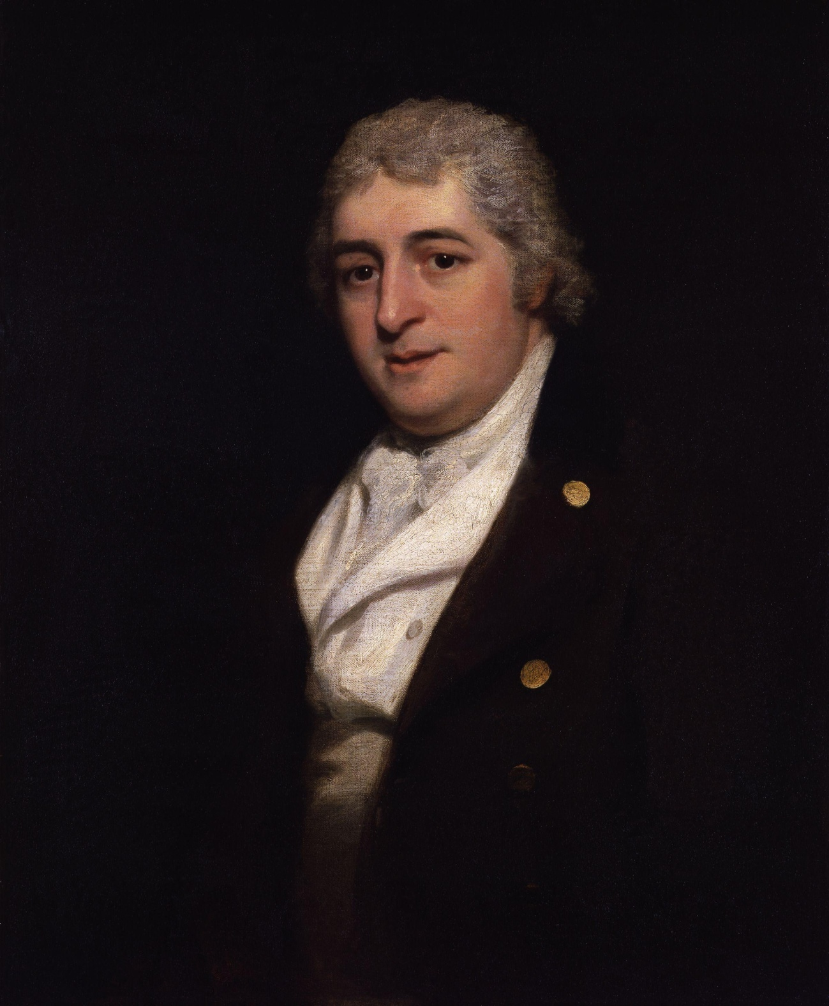
Charles Dibdin (before 4 March 1745 – 25 July 1814) was a British musician, songwriter, dramatist, novelist and actor.
Text 1. The National Germanic Alphabet

Task 1. Read the texts using the Jigsaw reading technique.
Part I.
WHEN the English still lived in their continental homes they shared with the neighbouring kindred tribes an alphabet which may well be described as the national Germanic alphabet, since there is evidence that it was used throughout the Germanic territory, both in the outposts of Scandinavia and in the countries watered by the Rhine and the Danube.
The origin of this early script is obscure; some writers hold that it was borrowed from the Latin alphabet, whereas others think that it was of Greek origin. From its wide use amongst the Germanic tribes, we must, perforce, conclude that it was of considerable antiquity, at all events older than the earliest Scandinavian inscriptions, which, in all probability, go back as far as the third century of our era.
That it was used in the fourth century is proved since, at that time, Ulfilas, bishop of the West Goths, had borrowed from it the signs of u and o for his newly-constructed alphabet.
Moreover, there can be no doubt that the Goths must have brought the knowledge of it from their early homes in the north before the great wave of the Hunnish invasion swept them away from kith and kindred, finally setting them down on the shores of the Danube and the Black Sea.
The name of these early Germanic characters seems also to have been the same amongst all the tribes. Its Old English form, rùn, differs little from the corresponding early German or Scandinavian forms, and the meaning of the word (mystery, secret, secret counsel) seems also widely spread. This word lived on through Middle English times, and a derivative rùnian appears in Shakespeare as roun or round (a form still retained in the expression “to round in one’s ear”). The separate letters were known as rùnstafas.

Part II.
The runes were, in all probability, originally carved in wood, and sometimes filled in with red paint to make them more distinct. The technical term for this cutting or engraving is, in Old English, wrìtan, which, in its transferred meaning of “to write,” has survived to the present day. The wood was fashioned into tablets or staves, as we learn from the well-known lines of Venantius Fortunatus, a writer of the sixth century who refers to the barbaric rune as being painted on tablets of ashwood or smooth sticks.

A sample from the Visigoth Scriptures (Luke 15:11-22)
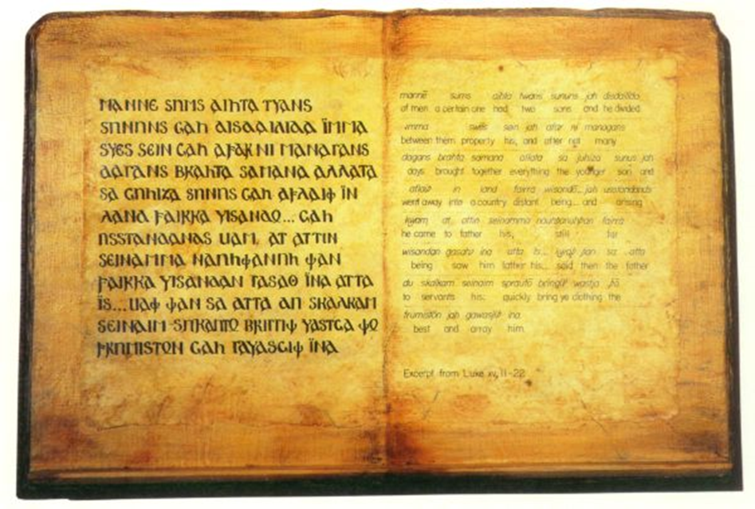
Such a tablet was originally called bòc (a tablet of beechwood), and may be regarded as the ancestor, in a double sense, of the modern word “book.” Other materials used were metal, principally in the form of weapons, coins, rings and other ornaments, household and other implements; drinking-horns were often adorned with runic inscriptions, and runes have also been found on smaller objects of horn and bone. Moreover, in England and Scandinavia there occur runic inscriptions on stone monuments, and there are also some which have been hewn out of rocks. Parchment seems to have been introduced at a late period, and, of the few manuscripts remaining entirely written in runes, none go back further than the thirteenth century.
(The Cambridge History of English and American Literature in 18 Volumes (1907–21). Volume I. From the Beginnings to the Cycles of Romance. II. Runes and Manuscripts. § 1. The National Germanic Alphabet. Доступ з: http://www.bartleby.com/211/0201.html)

Ulfilas (311-382)
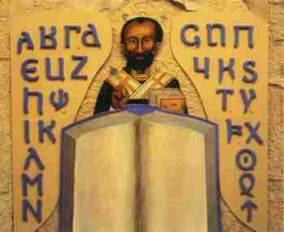

Task 2. Discuss the text “The National Germanic Alphabet”, highlight the main ideas and speak on the following:

a) Ulfilas, bishop of the West Goths;

b) the Hunnish invasion;

c) Venantius Fortunatus.

Text 2. Runes in Scandinavian and Old English Literature.

Task 1. Read the texts using the Jigsaw reading technique.
Part I.
There is considerable uncertainty as to the earliest purpose of the runes, whether they were originally used as real characters of writing, or, as the name suggests, as mystical signs, bearers of potent magic. But, since the power and force of the spoken word easily pass into the symbol for which it stands, it is not improbable that the latter meaning is secondary, the spell becoming, so to speak, materialized in the graven letter, and, even in this form, retaining all its original power for good or evil.
For the earliest Germanic literature abounds in proofs of the magic nature of runes; from the Edda poems down to the latest folk-songs of the present day there is continuous evidence of their mystic influence over mankind.
Runes could raise the dead from their graves; they could preserve life or take it, they could heal the sick or bring on lingering disease; they could call forth the soft rain or the violent hailstorm; they could break chains and shackles or bind more closely than bonds or fetters; they could make the warrior invincible and cause his sword to inflict none but mortal wounds; they could produce frenzy and madness or defend from the deceit of a false friend.
Their origin was, moreover, believed to be divine, since Odin is represented in the Edda as sacrificing himself in order to learn their use and hidden wisdom. Odin was also the greatest “runemaster” of the ancient Germanic world, and Saxo relates how the god sometimes stooped to use them for purposes of personal revenge. A cold-hearted maiden who rejected his suit he touched with a piece of bark, whereon spells were written. This made her mad; but according to Saxo, it was “a gentle revenge to take for all the insults he had received.”
Saxo also relates a gruesome tale how, by means of spells engraved on wood, and placed under the tongue of a dead man, he was forced to utter strains terrible to hear, and to reveal the no less terrible secrets of the future. In the Icelandic Sagas, references to the supernatural power of the runes are equally explicit.
“Edda” poems
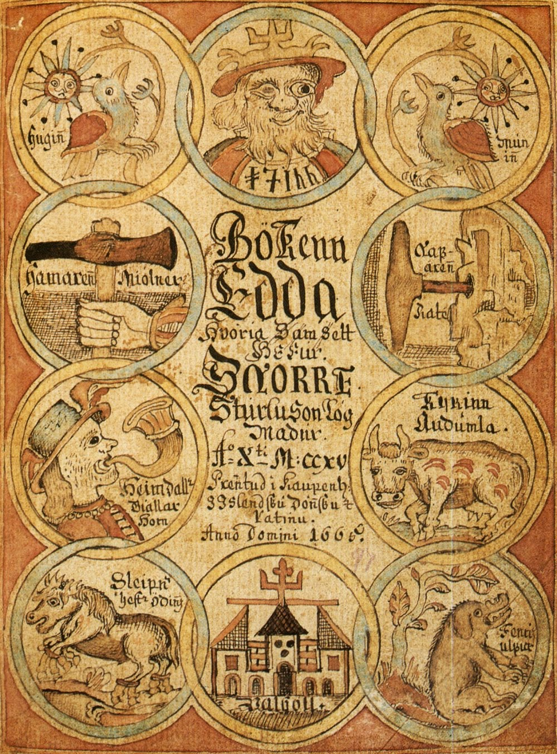
Odin
.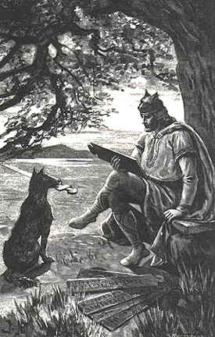
Saxo Grammaticus
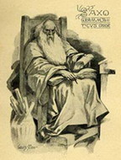
In the Saga of Egill Skallagrìmsson, who lived in the tenth century, it is told how a maiden’s illness had been increased because the would-be healer, through ignorance, cut the wrong runes, and thus endangered her life. Egill destroys the spell by cutting off the runes and burning the shavings in the fire; he then slips under the maiden’s pillow the staff whereon he had cut the true healing runes. Immediately the maiden recovers.
The Icelandic sagas.
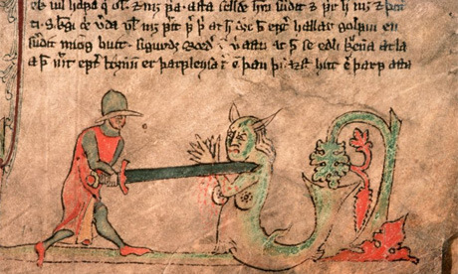

Part II.
Side by side with the early magic use of runes there is also clear evidence that, at an earlier period, they served as a means of communication, secret or otherwise. Saxo relates, in this respect, how Amlethus (Hamlet) travelled to England accompanied by two retainers, to whom was entrusted a secret letter graven on wood, which, as Saxo remarks, was a kind of writing-material frequently used in olden times. In the Egilssaga mentioned above, Egill Skallagrmìsson’s daughter Thorger[char]r is reported to have engraved on the rùnakefli or “runic staff” the beautiful poem Sunatorrek, in which her aged father laments the death of his son, the last of his race.
The rùna-kefli of the Icelandic Sagas
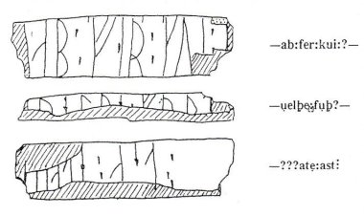
These few instances, taken from amongst a great number, prove that runes played an important part in the thoughts and lives of the various Germanic tribes. The greater number of runic inscriptions which have come down to our times, and by far the most important, are those engraved on stone monuments. Some of these merely bear the name of a fallen warrior, while others commemorate his exploits, his death, or his life as a whole. These inscriptions on stones and rocks occur only in England and Scandinavia, from which fact we may, perhaps, infer that this use of runes was a comparatively late development. Some of the very earliest extant inscriptions may be regarded as English, since they are found either within Angeln, the ancient home of the nation — for instance, those of Torsbjaerg, — or not far from that district.
Part III.
From what has been said, it is clear that the English, on their arrival in this island, must have been conversant with their national alphabet, and the various uses thereof. It may be worth-while to examine somewhat more closely its original form and the changes which it underwent after the migration. In its early Germanic form the runic alphabet consisted of twenty-four signs, usually arranged in three sets of eight which, from their respective initial letters, bore in Old Norse the names of Freyr and Hagall. The alphabet itself is generally known as the fupark from the first six of its letters. Each rune had a name of its own, and a well-defined place in the alphabet.
A gold coin at Vadstena in Sweden (450-550). Old Futhark.
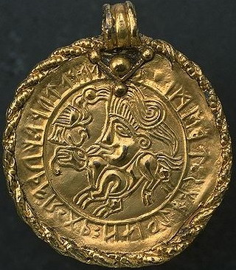
The order is specifically Germanic, and can be ascertained from old alphabets found on a gold coin at Vadstena in Sweden, and on a silver-gilt clasp dug up at Charnay in Burgundy. After the migration and subsequent isolation of the English, it became necessary, in course of time, to modify the early alphabet and to make it more conformable with the changing sounds of the language. Four new signs were added, and some of the older ones modified in order to represent the altered value of the sounds. Thus there arose a specifically Old English alphabet, of which not less than three specimens have been preserved. One of these is on a small sword found in the Thames and now in the British Museum; another is contained in the Salzburg manuscript 140 of the tenth century, now at Vienna; the third occurs in an Old English runic song. The last two, moreover, present the names of the runes in their Old English form. Apart from the standard English type found in the above-mentioned three alphabets, a local Norwegian variety, of a far simpler character, was current in the Isle of Man, as appears from certain Norse inscriptions there, dating from the latter half of the eleventh century.
Part IY.
It is, however, difficult to determine in what manner and to what extent runes were used by the English settlers, for here the evidence is by no means as abundant and explicit as in the far north. Christianity was introduced into England at an early period, centuries before it was brought to distant Scandinavia, and the new religion laboured, and laboured successfully, to eradicate all traces of practices and beliefs that smacked of the devil, with which potentate the heathen gods soon came to be identified.
The Venerable Bede.
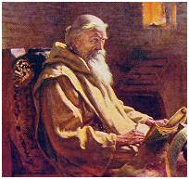

Nevertheless, we have some evidence, which, despite its scantiness, speaks eloquently of the tenacity of old beliefs, and the slow lingering of superstition. Bede furnishes us with a striking proof that the English, at a comparatively late date, believed in the magic properties of runes. In his Historia Ecclesiastica (IV, 22) he relates the fate of a nobleman called Imma, who was made a prisoner in the battle between Ecgfrith, king of Northumbria, and Aethelred, king of Mercia, A.D. 679, and whose fetters fell off whenever his brother, who thought him dead, celebrated mass for the release of his soul. His captor, however, who knew nothing about the prayers, wondered greatly, and inquired whether the prisoner had on him litterae solutoriae, that is, letters which had the power of loosening bonds. Again, in Beowulf (1. 59I), a person who broached a theme of contention is said to “unbind the runes of war.”
Pater Noster.
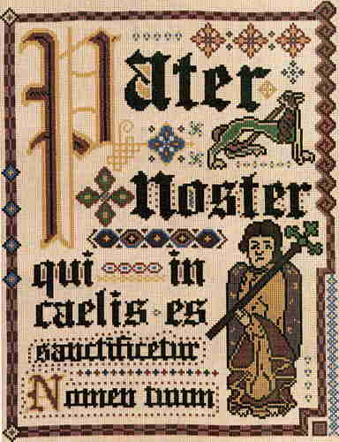

In the poem called Daniel (1. 74I), the mysterious and terrible writing on the wall of Belshazzar’s palace is described as a rune. In the Dialogue of Salomon and Satur there is a curious travesty of an old heathen spell. In treating of the powers and virtues of the Pater Noster, the poet gradually inserts all the runes that serve to make up the prayer, each, however, being accompanied by the corresponding Latin capital letter. Thereupon he advises every man to sing the Pater Noster before drawing his sword against a hostile band of men, and also to put the fiends to flight by means of God’s word; otherwise they will stay his hand when he has to defend his life, and bewitch his weapon by cutting on it fatal letters and death signs.
The one and only manuscript of 'Beowulf'
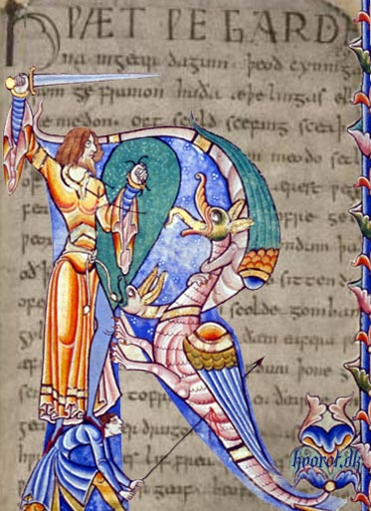
We could scarcely wish for a better illustration of the way in which Christianity combated the old beliefs, substituting the Pater Noster for the ancient heathen war-spell, reading a new meaning into the old rites and shifting to fiends and devils the power of making runes of victory or of death, a power formerly in the hands of pagan gods.
When used as ordinary writing characters, without any taint of magic, runes appear to have met with more tolerant treatment. The earliest inscriptions extant in this country consist mainly of proper names, in most cases those of the owners of the engraved article. The Thames sword, for instance, bears, in addition to the runic alphabet, the name of its owner, Beagnop.
Again, Beowulf is represented as finding in Grendel’s cave a sword of ancient workmanship, with rune-staves on the hilt, giving the name of the warrior for whom the sword had first been made.
Similarly, an eighth century ring bears, partly in runic, partly in Roman, characters, the legend “Æ[char]ed owns me, Eanred engraved me.” There are also references in Old English literature to the use of runes as a means of communication.
We are reminded of the rùna-kefli of the Icelandic sagas on reading the little poem called The Husband’s Message, where a staff, inscribed with runes, is supposed to convey to a wife the message of her lord, bidding her cross the sea in search of the distant country where he had found gold and land.
(The Cambridge History of English and American Literature in 18 Volumes (1907–21). Volume I. From the Beginnings to the Cycles of Romance. II. Runes and Manuscripts. § 1. The National Germanic Alphabet. Доступ з: http://www.bartleby.com/211/0202.html)

Task 2. Discuss the text “Runes in Scandinavian and Old English Literature”, highlight the main ideas and speak on the following:
a) the magic nature of runes;
b) Edda poems;
c) Odin - a major god in Norse mythology;
d) litterae solutoriae.

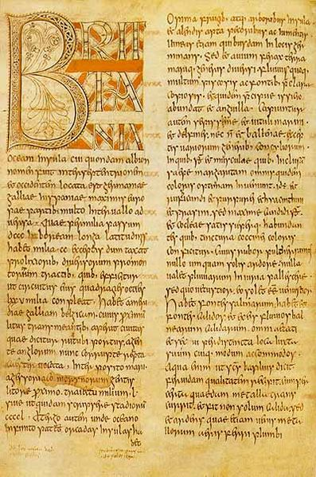
The Historia ecclesiastica gentis Anglorum (in English: Ecclesiastical History of the English People) is a work in Latin by Bede on the history of the Christian Churches in England, and of England generally; its main focus is on the conflict between Roman and Celtic Christianity.

Text 3. Runic Inscriptions.
Task 1. Read the texts using the Jigsaw reading technique.
Part I. The Franks Casket.
Runic inscriptions have, moreover, been discovered on coins and various other objects, the most important being the beautiful Clermont or Franks casket. The top and three of the sides are now in the British Museum, the fourth side is in the Museo Nazionale at Florence. The casket is made of whalebone, and the scenes carved on it represent an episode from the Welandsaga, the adoration of the Magi, Romulus and Remus nursed by the she-wolf and, lastly, a fight between Titus and the Jews.
The carving on the Florence fragment is still unexplained. The legends engraved around these episodes are intended to represent the capture of the whale and to elucidate the carving. On linguistic grounds it has been thought probable that the casket was made in Northumbria at the beginning of the eighth century.
The Franks Casket, an Anglo-Saxon box made of whale's bone, 8th century.
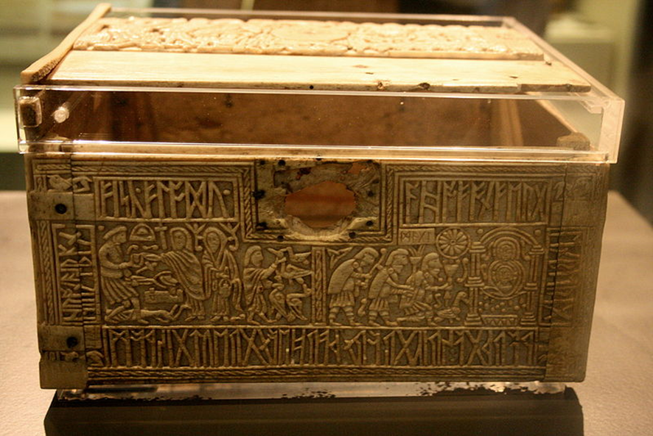
In several Old English MSS. runes are found in isolated cases, for instance in Beowulf, and in the Durham Ritual. In the riddles of the Exeter Book the occasional introduction of runes sometimes helps to solve the mystery of the enigma, and sometimes increases the obscurity of the passage. Occasionally a poet or scribe will record his name by means of a runic acrostic introduced into the text. Thus, the poems Crist, Juliana, Elene and the Vercelli fragment bear the runic signature of their author, Cynewulf.
(The Cambridge History of English and American Literature in 18 Volumes (1907–21). Volume I. From the Beginnings to the Cycles of Romance. II. Runes and Manuscripts. § 1. The National Germanic Alphabet. Доступ з: http://www.bartleby.com/211/0203.html)

Part II. The Ruthwell Cross.
But still more important are those inscriptions which have actually survived and which are mainly found on stone monuments. They are confined almost exclusively to the north, and the greater number of them belong to the seventh and eighth centuries, for absolutely no inscriptions have survived from the first one hundred and fifty years subsequent to the English invasion.
These inscriptions are almost all due to Christian influence. Chief among these monuments, so far as English literature is concerned, are the Ruthwell Cross in Dumfriesshire, possibly dating back to the eighth century, on which are inscribed extracts from The Dream of the Rood, and the Bewcastle Column in Cumberland, probably erected to the memory of Alchfrith, son of the Northumbrian king Oswy (642-670).
Task 2. Discuss the text “Runic Inscriptions”, highlight the main ideas and speak on the following:
a) the Ruthwell Cross in Dumfriesshire;
b) “The Dream of the Rood” poem;
c) the Bewcastle Column in Cumberland;
d) the riddles of the Exeter Book;
e) Cynewulf one of twelve Anglo-Saxon poets.

The Ruthwell Cross in Dumfriesshire
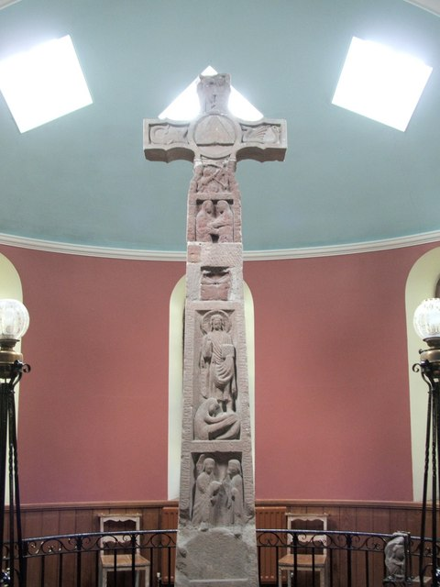
Bewcastle runic Column in Cumberland
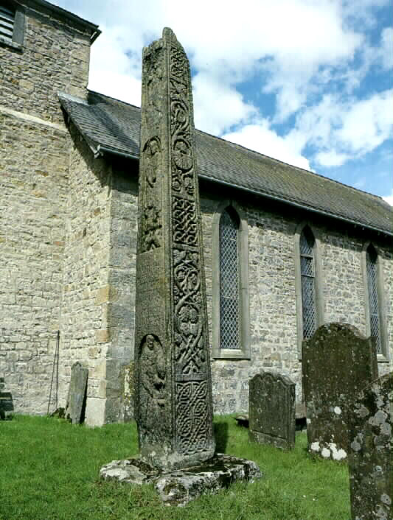
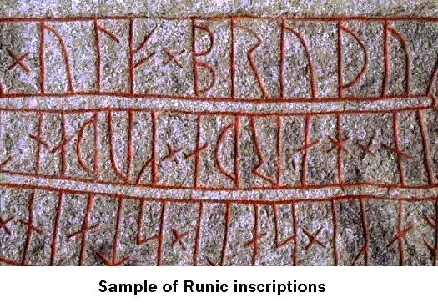
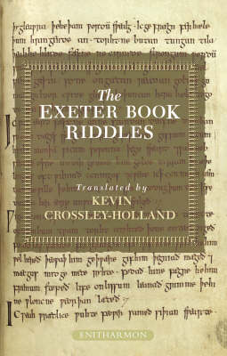
Text 4. The Roman Alphabet.

Task 1. Read the texts using the Jigsaw reading technique.
Part I.
Runes went out of use during the ninth and tenth centuries. Their place had, however, been usurped long before that period by the Roman alphabet, which the English received from the early Irish missionaries.
The Irish missionaries
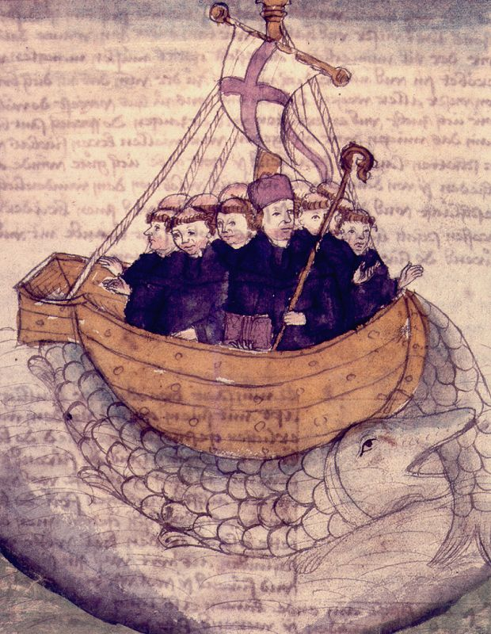
The advent of Christianity and the beginnings of English literature are intimately connected, for the missionary and the Roman alphabet travelled together, and it was owing to the Christian scribe that the songs and sagas, the laws and customs, the faith and the proverbial wisdom of our forefathers, were first recorded and preserved.
The Roman alphabet
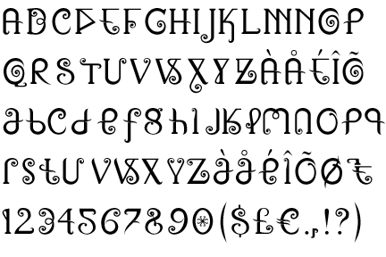
It is, indeed, difficult to realize that, before the conversion of the English to Christianity, during the sixth and seventh centuries, the whole, or, at all events, by far the greater part, of the intellectual wealth of the nation was to be sought on the lips of the people, or in the retentive memory of the individual, and was handed down from generation to generation by means of song and recitation.
Caesar Lands in Britain, August 27 55BC

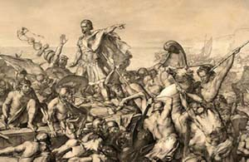
Caesar relates how this was the case in Gaul, where the accumulated wisdom of the Druids, their religion and their laws, were transmitted by oral tradition alone, since they were forbidden to put any of their lore into writing, although, for other purposes, the Greek alphabet was used.
The Druids' Temple, near Masham in Wensleydale, in the Yorkshire Dales
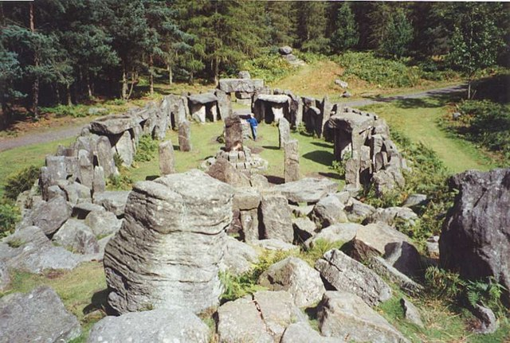
What wonder if the young Gauls who served their apprenticeship to the Druids had, as Caesar says, to learn “a great number of verses,” and often to stay as long as twenty years before they had exhausted their instructors’ store of learning.
Part II.
Before entering, however, on the history of the Irish alphabet in England, it may be of interest to note that an even earlier attempt had been made to introduce Roman characters among the English. This was due to the efforts of Augustine and his missionaries, who established a school of handwriting in the south of England, with Canterbury as a probable centre.
A Psalter of about A.D. 700, now in the Cottonian collection of the British Museum, and a few early copies of charters constitute, however, the only evidence of its existence that survives. From these we learn that the type of alphabet taught was the Roman rustic capital though of a somewhat modified local character. This paucity of records makes it seem likely that the school of the Roman missionaries had but a brief period of existence, and wholly failed to influence the native hand.
(The Cambridge History of English and American Literature in 18 Volumes (1907–21). Volume I. From the Beginnings to the Cycles of Romance. II. Runes and Manuscripts. § 1. The National Germanic Alphabet. Доступ з: http://www.bartleby.com/211/0204.html)
A Psalter of about A.D. 700, now in the Cottonian collection of the British Museum
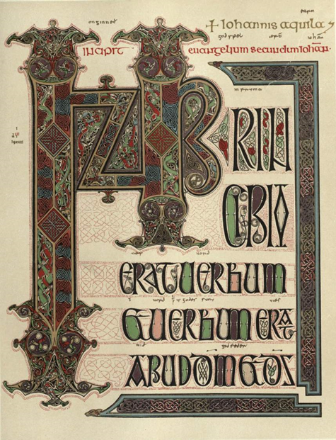
Task 2. Discuss the text “The Roman Alphabet”, highlight the main ideas and speak on the following:
a) the Druids;
b) Augustine and his missionaries.
St. Augustine, Archbishop of Canterbury, Apostle of the English.
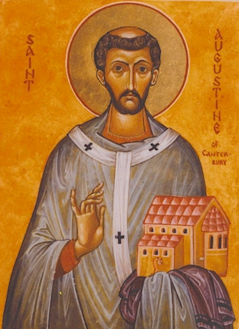
Text 5. Tablets, Parchment, Vellum, Paper, Pens, Ink, and Binding.

Task 1. Read the texts using the Jigsaw reading technique.
Part I.
Turning to the materials used for writing in medieval England, we gain at once a connecting link with the runic alphabet, since the wooden tablet, the bòc, again appears, though in a somewhat different fashion. A thin coating of wax was now spread over the surface, and the writing was scratched on it with a pointed instrument of metal or bone which, in Old English, was known as graef, and in the later centuries by the French term poyntel.

Wooden tablets filled with wax represent the “earliest known form of ancient book”
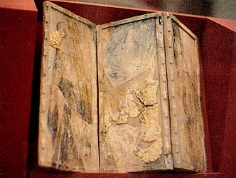
The use of these tablets was widely, spread in the Middle Ages; they served for the school-boy’s exercises and for bills and memoranda of every description, for short letters and rough copies — for anything that was afterwards to be copied out, more carefully, on vellum. In German illuminated MSS. poets are represented as writing their songs and poems on waxen tablets, and, as early as the sixth century, The Rule of St. Benet makes provision for the distribution of tablets and styles to monks.
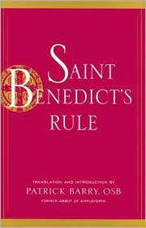
Wall plaque at the Catholic Church of St Aldhelm, Malmesbury. The inscription says 'St Aldhelm 639-709, Abbot of Malmesbury and Bishop of Sherborne, Latin Poet and Ecclesiastical Writer. '
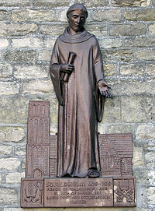
There is, also, evidence of the use of these tablets by Irish monks, who, it may be supposed, would introduce them to their English pupils. And, consequently, we find that Aldhelm, who died in 709, writes a riddle of which the answer is “tablet”—a fact which presupposes a knowledge of the existence of tablets among his contemporaries. Again, in Ethelwold’s Benedictionale of the tenth century, Zacharias (Luke, i, 3) is represented as writing on a waxen tablet.
In the twelfth century we learn concerning Anselm, archbishop of Canterbury ([char]1109), that he was in the habit of making the first sketch of his works on waxen tablets; and, in The Canterbury Tales, Chaucer relates how the summoner’s “fellow” had “a pair of tables all of ivory, and a poyntel ypolished fetisly.”
Far more important, practical and durable as writing material, however, was parchment or vellum, the use of which prevailed throughout the Middle Ages. The Old English name for this was bòc-fel, literally “book-skin,” replaced in Middle English by the French terms parchment and velin (vellum). These terms, originally, were not interchangeable, vellum being, as its name indicates, prepared from calf-skins, parchment from sheep-skins.
Statue of St. Anselm, Archbishop of Canterbury, from the exterior of Canterbury Cathedral.
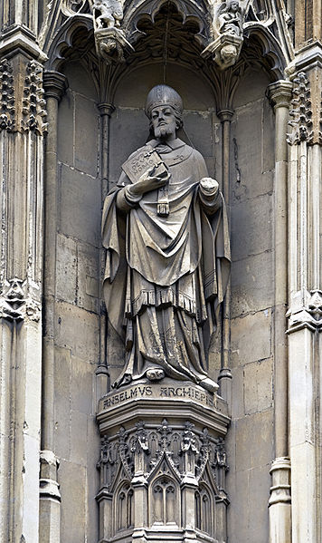
At first, the evidence goes to show that monasteries had to prepare their own parchment, either by the help of the monks themselves or of laymen engaged for the purpose. Later, however, the parchment-makers took their place as ordinary craftsmen, and supplied religious and other houses with the necessary material.
Thus we find that, in the year 1300, Ely bought five dozen parchments and as many vellums, and, about half a century later, no less than seventy and thirty dozen respectively in order to supply the want of writing material for a few years only. Vellum was, at times, magnificently coloured, the text being, in such cases, inscribed in letters of gold or silver.
The most famous example is the Codex argenteus at Upsala. Archbishop Wilfrid of York (664—709) is said to have possessed the four Gospels written on purple vellum in letters of purest gold, a fact which his biographer records as little short of the marvellous. In the British Museum there remains to this day an Old English MS. of the Gospels the first leaves of which are written in golden letters on purple vellum.
Codex Argenteus. location: Uppsala, Universitetsbibliotek
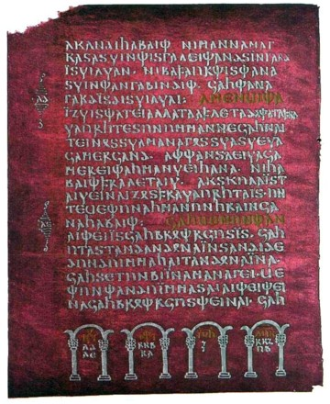
Part II.
Apart from these èditions de luxe, which naturally must have been of enormous cost, ordinary working parchment was a very expensive writing material, and it is small wonder if, on that account, it gradually had to give way before a new and less costly material.
It appears that, from times immemorial, the manufacture of paper from linen rags and hemp was known to the Chinese, who, apparently, taught their art to the Arabs, since paper was exported by that nation at an early date. In the twelfth century paper was known in Spain and Italy, and thence it spread slowly northwards, though it did not come into more general use until the fourteenth century.
In the fifteenth century paper manuscripts were very frequent in England, as can be assumed from the great number still remaining in public and private libraries. For writing, both on parchment and on paper, the quill was used, known in Old English times as fe[char]er in Middle English by the French term penne. The existence of the quill as an implement of writing is proved by one of the oldest Irish MSS., where St. John the Evangelist is represented holding a quill in his hand. Again, Aldhelm has a riddle on penna, in the same way as he had one on the tablet.
An ink-horne
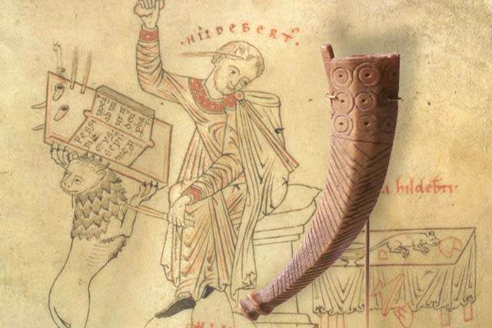
Other necessary implements for writing and preparing a MS. were a lead for ruling margins and lines, a ruler, a pair of compasses, scissors, a puncher, an awl, a scraping-knife and, last but not least, ink, which was usually kept in a horn, either held in the hand by the scribe, or placed in a specially provided hole in his desk.
In Old English times it was known, from its colour, as blaec, but, after the Conquest, the French term enque, our modern English ink, was adopted. The terms horne and ink-horne are both found in old glossaries. When the body of the text was finally ready, the sheets were passed to the corrector, who filled the office of the modern proof-reader, and from him to the rubricator, who inserted, in more or less elaborate designs, and in striking colours, the rubrics and initials for which space had been left by the scribe.
The opening pages of Beowulf in the Beowulf manuscript, anonymous, c AD1000, in Old English
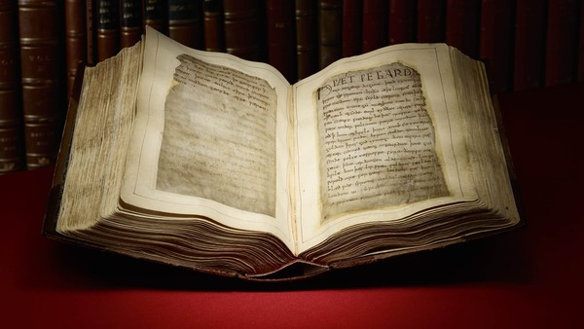
The pieces of parchment were then passed to the binder, who, as a rule, placed four on each other and then folded them, the result being a quire of eight leaves or sixteen pages. The binding was generally strong and solid in character: leather was used for the back and wooden boards for the sides, which were usually covered with parchment of leather or velvet. Thus was established the form and fashion of the book as we know it, whether written or printed. Besides the book-form, parchment was also made up into rolls, which were especially used for chronological writings and deeds of various kinds.
(The Cambridge History of English and American Literature in 18 Volumes (1907–21). Volume I. From the Beginnings to the Cycles of Romance. II. Runes and Manuscripts. § 1. The National Germanic Alphabet. Доступ з: http://www.bartleby.com/211/0205.html)

Task 2. Discuss the text “Tablets, parchment, vellum, paper, pens, ink, and binding”, highlight the main ideas and speak on the following:
a) “The Rule of St. Benet”;
b) Aldhelm, Abbot of Malmesbury Abbey, Bishop of Sherborne, Latin poet and scholar of Anglo-Saxon literature;
c) Anselm, archbishop of Canterbury;
d) the Codex argenteus;
e) Archbishop Wilfrid of York.
Archbishop Wilfrid of York
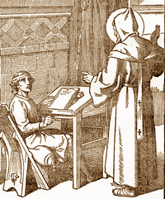
Text 6. Scribes and scriptoria.

Task 1. Read the texts using the Jigsaw reading technique.
Part I.
The men who wrote both roll and book, and to whose patience and devotion we owe so much of our knowledge of the times gone by, were, at first, the monks themselves; it being held that copying, especially of devotional books, was a work pleasing to God and one of the best possible ways in which men, separated from the world, could labour.

Scriptorium.
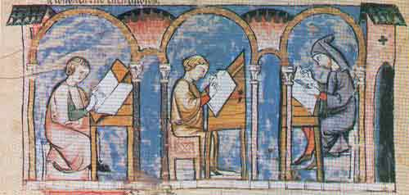
Gradually, however, there grew up a professional class of scribes, whose services could be hired for money, and who can be proved to have been employed at an early period in the monasteries of England and abroad. Nuns were also well versed in writing. Moreover, where schools were attached to monasteries the alumni were early pressed into service, at all events to copy out books needed for their own instruction.
The cloister was the centre of life in the monastery, and in the cloister was the workshop of the patient scribe. It is hard to realize that the fair and seemly handwriting of these manuscripts was executed by fingers which, on winter days, when the wind howled through the cloisters, must have been numbed by the icy cold. It is true that, occasionally, little carrells or studies in the recesses of the windows were screened off from the main walk of the cloister, and sometimes a small room or cell would be partitioned off for the use of a single scribe. This room would then be called the scriptorium, but it is unlikely that any save the oldest or most learned of the community were afforded this luxury. In these scriptoria of various kinds the earliest annals and chronicles in the English language were penned, in the beautiful and painstaking forms in which we know them.

Scriptorium monk at work
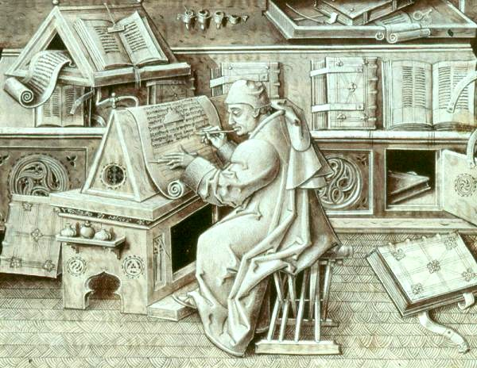
Part II.
There is no evidence for the existence of buildings specially set apart for libraries until the later Middle Ages. Books were stored in presses, placed either in the church or in convenient places within the monastic buildings. These presses were then added to as need arose, or, perhaps, a small room was set apart for the better preserving of the precious volumes. Books were frequently lost through the widespread system of lending both to private persons and to communities, and, though bonds were solemnly entered into for their safe return, neither anathema nor heavy pledges seemed sufficient to ensure the return of the volumes. But all losses through lending, or fire, or pillage, were as nothing compared with the utter ruin and destruction that overtook the literature of England, as represented by the written remains of its past, when the monasteries were dissolved. By what remains we can estimate what we have lost, and lost irrevocably. (The Cambridge History of English and American Literature in 18 Volumes (1907–21). Volume I. From the Beginnings to the Cycles of Romance. II. Runes and Manuscripts. § 1. The National Germanic Alphabet. Доступ з: http://www.bartleby.com/211/0206.html)

Task 2. Discuss the text “Scribes and scriptoria”, highlight the main ideas and speak on the following: a) the alumni; b) carrels; c) the scriptorium
Chapter II.
WORLD ALPHABETS IN SEVEN TEXTS.
Text 1. The Armenian Alphabet
This original script was created by the greatest Armenian enlightener Mesrop Mashtotz about 406 AD. The invention of the script was caused by the spreading of Christianity over Armenia in the 4th century, and by the necessity to create a writing for mystic literature in the Armenian language.
The issue of exact origin and prototype of the script is still unclear. However, general style of the construction (direction from the left, symbols for vowels, using letters for numbers etc.) makes us think it was invented under the influence of the Greek alphabet. It is also probable that Mashtotz could use one of the Aramaic scripts or the Pehlevi cursive script.
Mesrop Mashtotz (about 406 AD)
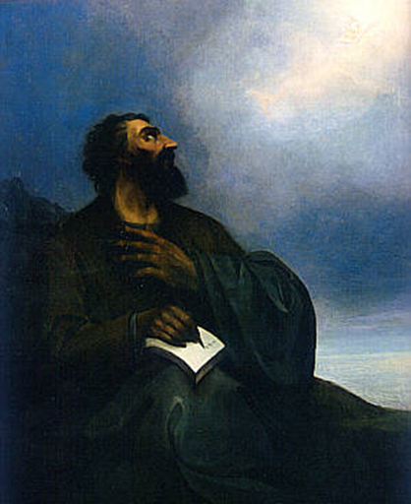
The alphabet is phonetic. It originally consisted of 36 simple symbols, each of them denoting a sound. Combinations of letters, as well as the diacritic signs, are not used in Armenian, except for the sound [u], composed of [o] + [w], and [ev] (from [e] + [w]). Both these signs were absent in the original alphabet. In the 12th century two other letters were included in the script: for denoting [o] and [f]. The latter was introduced to reflect numerous borrowed words in Armenian which contained [f]. This was the ultimate form of the alphabet which is used nowadays.
The only thing that changed a bit was the shape of letters. The modern Armenian alphabet is the descendant of the "round" variety, which was in use since the 12th century. The scripts looking like Armenian are Georgian and several other ancient Caucasian alphabets. Languages which use the script: Armenian only. (ndoeuro.bizland.com/project/script/armen.html)
The Armenian Alphabet
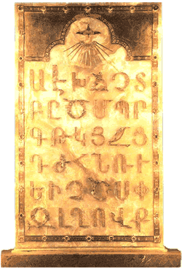

Tasks.
- Read the text and find some information on the topic of the text to answer the following questions:
- What does the term “a phonetic alphabet” mean?
- How are the diacritic signs used?
- What is the peculiar use of the Armenian alphabet?
- Find the keywords.
- Write a short essay about Mesrop Mashtotz, an Armenian theologian, linguist, hymnologist, who invented the Armenian alphabet.
Text 2. The Cyrillic Alphabet
This is one of the two ancient Slavic types of writing, which were invented, according to manuscripts, by St. Cyril, a Byzantine missionary who intended to convert Slavs into Christianity and decided to transcript the Bible into Slavic.
Distribution of the Cyrillic alphabet worldwide. The dark green shows the countries that use Cyrillic as the one main script; the lighter green those that use Cyrillic alongside another official script.
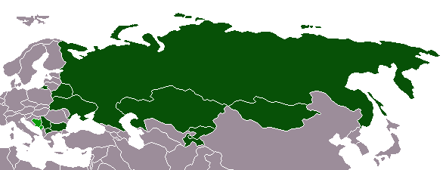
Modern scientific research shows that Cyrillic was invented later than the second alphabet, Glagolitic, but still in the second half of the 9th century. The source for the Cyrillic alphabet, which was formed in Bulgaria, is the Greek uncial alphabet. The letter composition of the original Cyrillic script fitted the old form of the Bulgarian language.
Many symbols of the alphabet were added in vain, for there were no sounds for them in Slavic; such letters are w, q, s, i and some others, later extinct. The Old Church Slavic language, the first which used Cyrillic, also introduced many diacritics to it: stress markers, aspiration markers etc., though there were no aspiration at all in Slavic. Besides, many signs for nasal vowels were invented for Slavic languages.
In the 10th and 11th centuries Cyrillic was in wide use in all countries populated by those Slavs who accepted Christianity - Bulgaria, Croatia, Serbia, Moravia. After 988, when Kiev Russia also took up Christianity, Cyrillic becomes the first Russian alphabet. The oldest texts and inscriptions in Cyrillic date from the 10th century (Bulgaria), from the 11st century (Russia), and from the 12th century (Bosnia and Serbia).
Cyril and Methodius
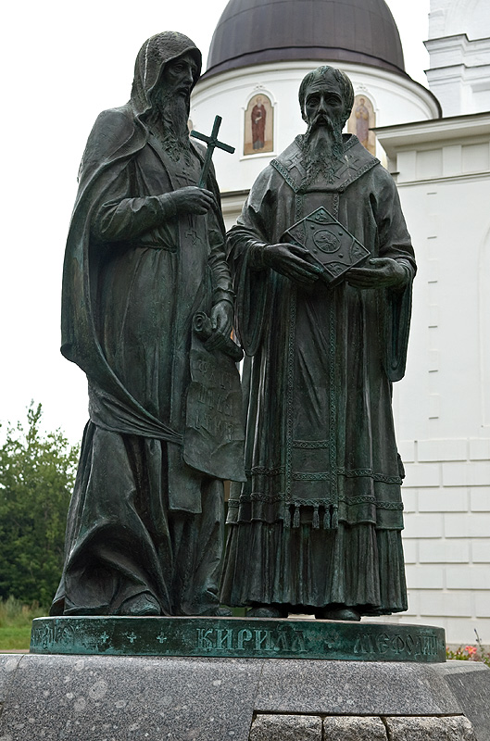
Gradually the number of letters, the shape of them and sometimes the pronunciation changed a little, together with changes in languages. The only language which preserves Cyrillic in its initial form is Old Church Slavic, the language for Orthodox cults in several East European countries.
The weakening influence of the Byzantine Empire gave way to Roman letters to replace Cyrillic in Europe: since the 16th century Czech and Polish kingdoms and the Lithuanian principality take up the Roman alphabet, in the 17th century the same happens in Romania. But in temples of those countries Cyrillic was used for two more centuries.
Cyrillic Alphabet
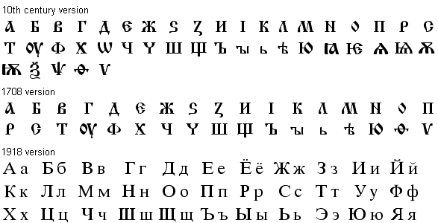
Nowadays Cyrillic is used in Russia, Bulgaria, Yugoslavia, Macedonia, Bosnia, Belorussia, Ukraine. Many alphabets of Asiatic nations are also based on Cyrillic, for it is much easier to learn than Arabic or Chinese. Therefore, Kazakhstan, Uzbekistan, Kirghizia, and Mongolia write in Cyrillic letters; earlier it was also in use in Azerbaijan, Tajikistan and Turkmenistan.
Languages which use the script: Slavic (Old Church Slavic, Russian, Serbo-Croatian, Bulgarian, Ukrainian, Belorussian, Macedonian), Iranian (Ossetic, Tati), non-Indo-European (Kazakh, Uzbek, Kirghiz, Mongolian, hundreds of languages of Russia). (http://indoeuro.bizland.com/project/script/cyril.html)
Tasks.
1. Read the text and find some information on the topic of the text to answer the following questions:
1) What is the second ancient Slavic type of writing invented by Saints Cyril and Methodius?
2) What are the common features of uncial script?
3) Can you prove the idea that many symbols of the Cyrillic Alphabet were added in vain?
- Find the keywords.
- Write a short essay about St. Cyril, a Byzantine missionary, who invented the Cyrillic and Glagolitic Alphabets.
Text 3. The Glagolitic Alphabet
While variants of the Cyrillic Alphabet have been in use to write Slavic (and some Central Asian, non-Slavic) languages for more than a thousand years, there was another alphabet, so called Glagolitic (from Old Church Slavic glagoliti meaning "to speak"), that was used side-by-side to Cyrillic in the early history of writing in Eastern Europe. The oldest recorded form of Slavic languages is Old Church Slavic, which used both Cyrillic (with 44 letters) and its version of Glagolitic.
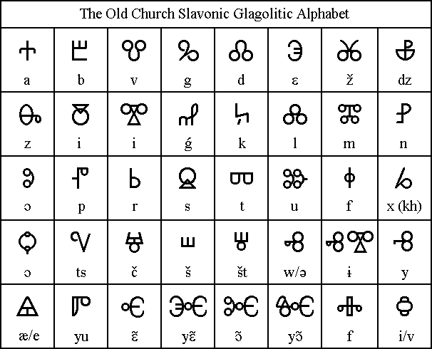

There were two brother missionaries in Saloniki in the 9th century, Cyril and Methodius, who once decided to create a special alphabet for the Slavs to read Christian books. The legend says that they formed Cyrillic and Glagolitic alphabets simultaneously; but in fact, according to historical documents, it seems that was Cyril who invented Glagolitic, and his brother and his pupils already made up Cyrillic.
The Glagolitic script was absolutely the same in symbol composition and in phonetics, but completely different in shape. The script is really very unique, that is why there is no sure about where it originated from. Some linguists state that its letters are connected with Greek, and some - even with the Samaritan and the Old Hebrew writing.
Bernard Comrie
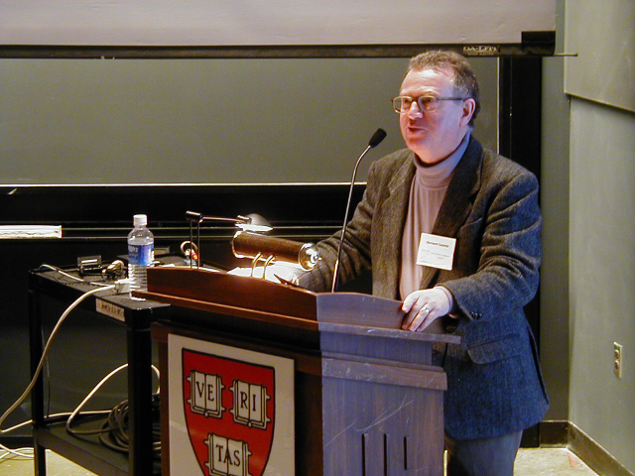
Alternatively, Bernard Comrie (of University of Southern California) came up with another reason for the competition between Glagolitic and Cyrillic. He theorized that Glagolitic came from cursive Greek scripts, while Cyrillic derived from Byzantine Greek uncial scripts already used in manuscripts. The students of Cyril might have found Glagolitic "undignified and unsuitable for ecclesiastical use" because of its cursive shapes, and derived Cyrillic from an already liturgical script. The script was in wide use in Moravia and Bohemia since the 9th language; then it penetrated to Bulgaria, Serbia and Croatia. It was seldom used also in Kiev Russia. In most places Glagolitic gave way to Cyrillic after the 12th century.
In Croatia, though, it continued to be in use until the 19th century in church. The Croatian Glagolitic is quite similar in to Old Church Slavonic Glagolitic, but it has less letters and the shape of its characters are much more rectangular. Languages which used the script: Slavic (Old Church Slavic, Serbo-Croatian, Old Czech, Bulgarian). (http://indoeuro.bizland.com/project/script/glago.html)
Glagolitic
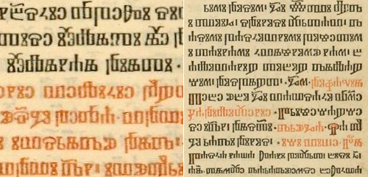
Tasks.
1. Read the text and find some information on the topic of the text to answer the following questions:
1) In what way did the Glagolitic script differ from the Cyrillic one?
2) What do you know about Old Church Slavic?
3) What are the ideas of some linguists concerning the origin of the Glagolitic Alphabet?
2. Find the keywords.
3. Write a short essay about Bernard Comrie, a specialist in linguistic typology and linguistic universals.
Text 4. The Gothic Alphabet
This unique script was used in all manuscripts written in Gothic and found in Europe. It is traditionally believed that its 27 letters were invented by bishop Wulfila (311-383). However, even a brief look at the alphabet assures that its basic system was borrowed from the Greek script of the 4th century. This can be understood from the shape of symbols, and from their sequence, as shown in the so called "Alquine Manuscript".
The Gothic alphabet
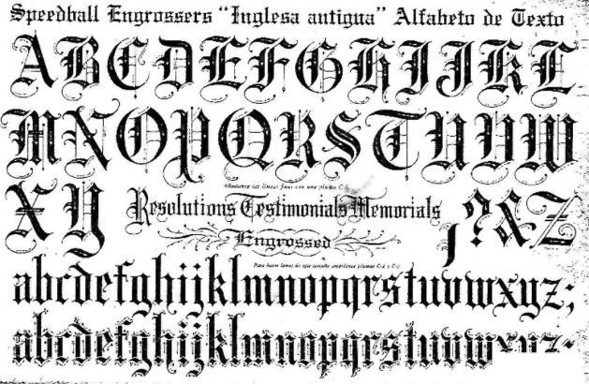
The Greek structure is also in using two letters for one long sound (like ei for the long sound [i]). Letters keep their mathematic meaning as figures as well as in Greek. Several letters cannot be connected with Greek though - h, s go back to the Roman alphabet, and u, o have probable Runic equivalents. Some symbols have different varieties: for example, s sometimes could seem like Roman s, sometimes like Greek sigma.
As a whole the Gothic alphabet follows well the phonetic system of the Gothic language. Wulfila was right when he decided to reflect labiovelar sounds, such as [hw] and [kw] by one letter. Moreover, voiced stop consonants and their fricative equivalents were also transcribed by a single letter.
Nevertheless, we should mention that the Gothic phonetics changed somehow from the time of Wulfila till the latest Gothic documents, and good connection between the language and the script was lost sometimes. Even now we are not clear about the exact sound of the following letters: ai, au, g).
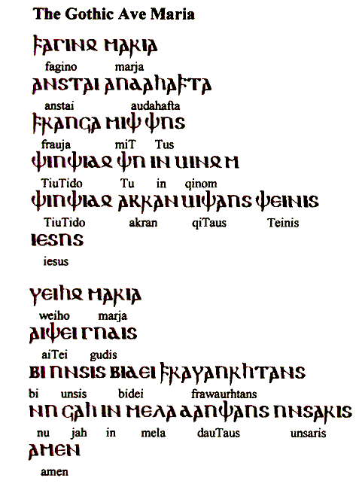
The alphabet was used till the 6th century, and was never written in other languages except Gothic itself. (http://indoeuro.bizland.com/project/script/gothi.html)
Tasks.
- Read the text and find some information on the topic of the text to answer the following questions:
- What scripts did the Gothic alphabet borrow the characters from?
- Why did Wulfila decide to invent his alphabet?
- What did the Arian historian Philostorgius say about Wulfila’s origin?
- Find the keywords.
- Write a short essay about Wulfila, bishop, missionary, and Bible translator, who is believed to invent the Gothic alphabet.
Philostorgius (born 368 B.C.E.) was a member of the Eunomian sect of Christianity, a nonconformist faction deeply opposed to the form of Christianity adopted by the Roman government as the official religion of its empire. He wrote his twelve-book Church History, the critical edition of the surviving remnants of which is presented here in English translation, at the beginning of the fifth century as a revisionist history of the church and the empire in the fourth and early-fifth centuries. Sometimes contradicting and often supplementing what is found in other histories of the period, Christian or otherwise, it offers a rare dissenting picture of the Christian world of the time.
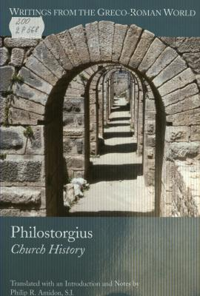
Text 5. The Greek Alphabet
The Greek alphabet goes back to the Phoenician script. It was transformed in the 9th century BC, and is by now considered the most ancient original Indo-European writing system. The more ancient Linear B script which was also used in Greece was completely borrowed by the non-Indo-European population of Crete and therefore cannot be taken into account as the original Indo-European one. The alphabet appeared the easiest and most comfortable for the Indo-European speech.
The Phoenician script
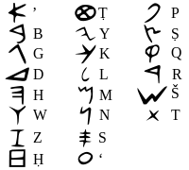
The earliest documents written in Greek date from the 8th century BC (inscriptions from Athens and from Phera). All its letters were practically the same as in Phoenician, later letters j, c, x, w, y were added. Its type and set of symbols are very close to the Old Phrygian alphabet, and even now linguists doubt about which alphabet was invented the first.
The Greek Alphabet
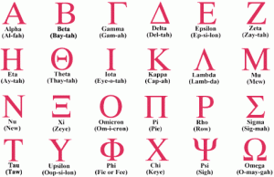
The alphabet had several significant advances comparing to the Semitic consonant prototype: first of all, special symbols denoting vowels appeared in Greek, which did not exist in Semitic - this was rather important for the progress of the Indo-European civilization. In the Classical period of the Greek history the script was used in two varieties: Western Greek and Eastern Greek. They differed in the way of writing a few symbols.
The Eastern alphabet later developed into classical Greek and Byzantine, later on its basis Cyrillic, Gothic and Coptic alphabets were worked out, as well as the Armenian and the Georgian scripts. As for the Western variety, it led to the creation of Italic, Etruscan, Roman and, as some scientists think, also the Germanic Runic scripts.
The classical alphabet in Greece consisted of 27 letters and was written from the left to the right. Later special symbols which were used only for mathematic figures - koppa, stigma, sampi - became extinct. In Doric, Arcadian and some other Greek dialects another symbol was used for the sound [w] which Attic and Ionian dialects had dropped before. This symbol was called digamma and was written as F. The New Greek alphabet nowadays uses 24 letters.
The Coptic alphabets
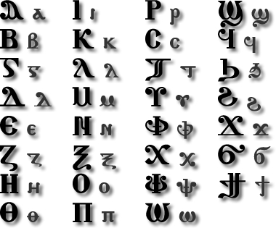
Georgian Alphabet
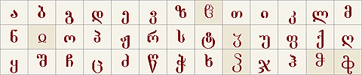
The Georgian script makes no distinction between upper and lower case. However, certain modern writers have experimented with using Asomtavruli letters (see below) as capitals.
Georgian Asomtavruli (Capital) Letters
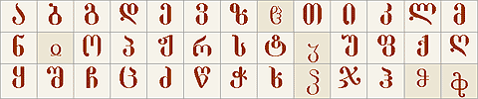
A 5th-century plate from Bolnisi with one of the oldest forms of the Georgian alphabet
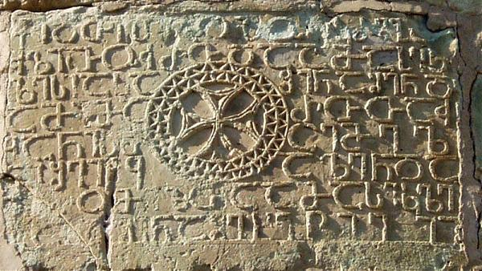
Languages which used the script: Hellenic (Ancient Greek and New Greek), and many nations of ancient Europe, Africa and Asia since the Hellenism epoch and till today. (http://indoeuro.bizland.com/project/script/greek.html)

Tasks.
- Read the text and find some information on the topic of the text to answer the following questions:
- Why is the Phoenician script called abjad?
- What do you know about the Old Phrygian alphabet?
- What are the numeral symbols for the words koppa, and sampi?
- Find the keywords.
- Write a short essay about the Hellenism epoch.
Text 6. The Italic and Etruscan Alphabets
Several alphabets, which were modified from the Western Greek script, are called Italic. They were used by Italic nations, and also by Etruscan, Venetic, Rhaetic people in ancient Italy.
Old Italic refers to several now extinct alphabet systems used on the Italian Peninsula in ancient times for various Indo-European languages (predominantly Italic) and non-Indo-European (e.g. Etruscan) languages. The alphabets derive from the Euboean Greek Cumaean alphabet, used at Ischia and Cumae in the Bay of Naples in the eighth century BC.
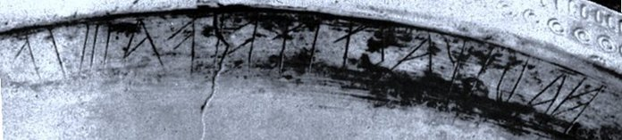

An old Latin legend says that writing was introduced in Italy by Aeneus even in the second millennium BC, long before Rome was founded. But that remained just a legend − for Romans to declare that their script, the Roman alphabet, was the most ancient in the country.
In fact, it was just one of Italic alphabets; they all were developed in about the 7th century BC. Another famous legend tells us that Romulus and Remus were taught literacy in Gabii, a town in Latium inhabited by Greek colonists − so actually the first Roman kings did not know writing at all.
Aeneas and Dido in Carthage, 1675 (oil on canvas) Photograph: Claude Lorrain/Getty Images /The Bridgeman Art Library
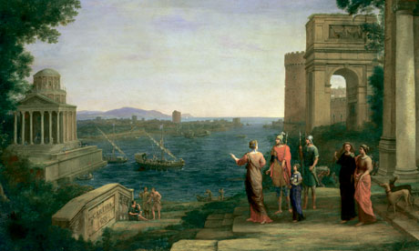
Romulus and Remus
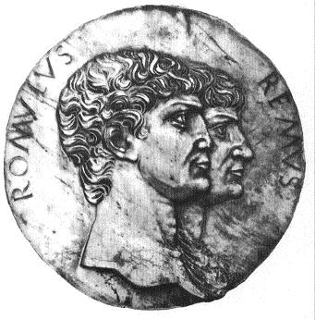
Archaeologists have found about 25 different varieties of the Italic alphabets in the country. The most widespread was the Etruscan script, or more correctly the Etruscan set of alphabets (about 8).
While the Roman script was borrowed directly from Greek, most of the rest Italic writing was transferred from Greek via Etruscan. This can be said about Oscan, Umbrian, Volscian alphabets. The Venetic script also derived from one of the north Etruscan alphabets, the same about Lepontic and Rhaetic languages.

Etruscan civilization

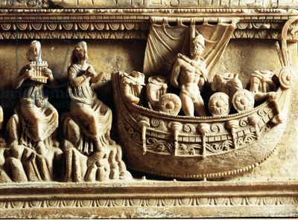
This is explained by the important Etruscan influence on all tribes in Italy at the time when writing spread over the country. Later, when Etruscan power was crushed, nations of Italy more likely accepted the Roman script. Since the 3rd century BC, about half of all Italic inscriptions, written in Oscan, Umbrian and other languages, were made in Roman. Soon all small varieties of Italic alphabets were forgotten, and the last inscription found in Etruscan dates from the 1st century AD.
The original Etruscan alphabet consisted of 26 letters and was written from the right (which is important, because most Indo-Europeans write from the left). It was taken directly from Western Greek, but the majority of symbols are reversed. Several letters are original and unique, they are believed to have been invented in Italy.
Oscan, Umbrian, Volscian, Venetic and other alphabets of Indo-European tribes accepted the Etruscan writing, but it appeared not quite convenient for Indo-European languages: for example, in Etruscan there was no sound [o], which coincided with [u], so Italic nations had to follow this rule and to write [u] instead of [o].
Nowadays it is therefore hard to say if there was [o] in Umbrian. In Etruscan fricatives could be only voiceless, there was no [b], [d], [g], and this also hardens the Italic script transliteration.
A strange sample of writing was found on the island of Lemnos in the Aegean Sea. Written in an alphabet close to Etruscan, it was made in the unknown language, also related somehow to Etruscan and Rhaetic.
Was it an Etruscan colony in the Aegean, or a relative nation, remained unclear. This Lemnos Stele is the only example of Italic inscriptions beyond Italy itself.
Languages which used Italic alphabets: Italic (Oscan, Umbrian, Volscian, Picene, Siculian), Venetic, Illyrian (Messapic), Celtic (Lepontic); non-Indo-European (Etruscan, Rhaetic, Sicanian, Lemnian).
(http://indoeuro.bizland.com/project/script/itali.html)
Tasks.
- Read the text and find some information on the topic of the text to answer the following questions:
1) What do you know about Aeneus? What is his legendary fate?
2) When was Rome founded?
3) What family did the Lepontic and Rhaetic languages belong to?
- Find the keywords.
- Write a short essay about the island of Lemnos.
Text 7. The Irish School of Writing.
The Irish alphabet was founded on the Roman half-uncial hand, manuscripts of this type having been brought over to Ireland by missionaries, perhaps during the fifth century.
Owing to the isolated position of the island and the consequent absence of extraneous influence, a strongly characteristic national hand developed, which ran its uninterrupted course down to the late Middle Ages. This hand was at first round in character and of great clearness, beauty and precision; but, at an early period, a modified, pointed variety of a minuscule type developed out of it, used for quicker and less ornamental writing.
The Irish alphabet.
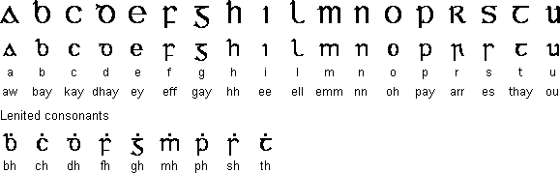
In the seventh century Northumbria was Christianized by Irish missionaries, who founded monasteries and religious settlements throughout the north.
Book/Manuscript: Lindisfarne Gospels VII-VIII Century, England
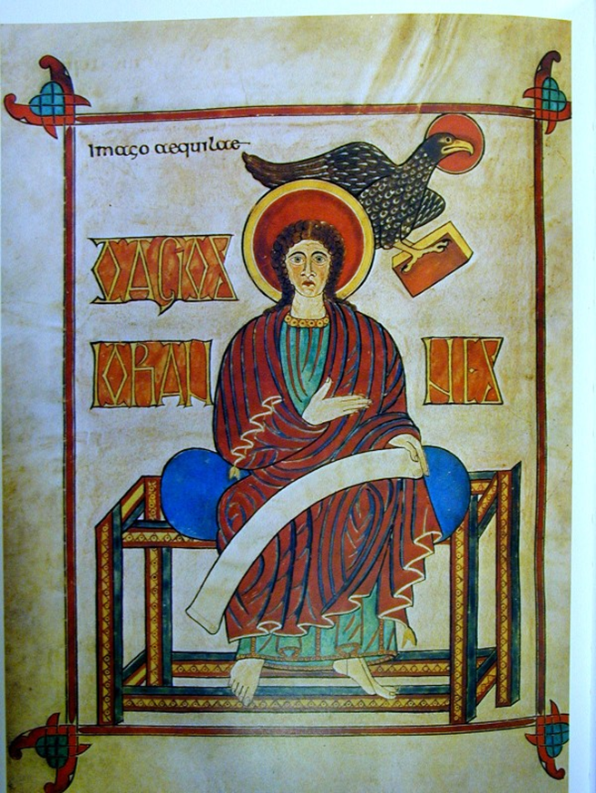
What, then, more natural than that these zealous preachers of the Word should teach their disciples not only the Word itself, but also how to write it down in characters pleasing to the Almighty, and not in rude and uncouth signs which conveyed all the power and magic of the heathen gods? Thus it came to pass that the English of the north learnt the exquisite penmanship of the Irish, and proved themselves such apt pupils that they soon equalled their former masters. In fact, the earliest specimens of the Northumbrian hand can scarcely be distinguished from their Irish models.
In course of time, moreover, the English threw off the conventions and restraints which fettered the Irish hand and developed a truly national hand, which spread throughout England, and which, in grace of outline and correctness of stroke, even surpassed its prototype.
St. Caedmon (Died AD 680)
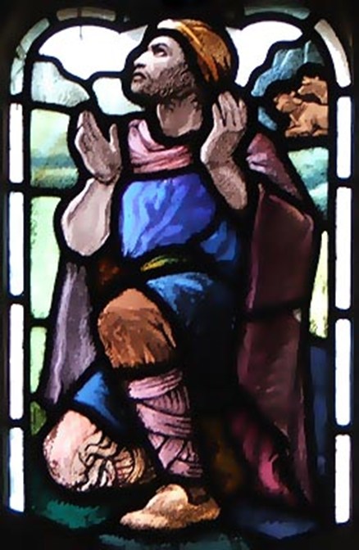
As might have been expected, the English adopted both the round and pointed varieties of their Irish teachers. One of the earliest and most beautiful examples of the former is The Book of Durham or The Lindisfarne Gospels, written about A.D. 700 by Eadfrith, bishop of Lindisfarne. And, as a specimen of the latter, may be mentioned a fine copy of Bede’s Ecclesiastical History in the University Library of Cambridge, written not long after 730, which possesses an additional interest as preserving one of the earliest pieces of poetry in the English language, The Hymn of Caedmon, in the original Northumbrian dialect. The pointed hand branched off into a number of local varieties and was extensively used down to the tenth century, when it became influenced by the French or Carolingian minuscule.
Towards the end of the century all Latin MSS. were, as a matter of fact, written in foreign characters, whereas the English hand came to be exclusively used for writing in the vernacular. For instance, a Latin charter would have the body of the text in the French minuscule, but the English descriptions or boundaries of the property to be conveyed would be written in the native hand.
After the Conquest, the native hand gradually disappeared, the only traces of it left being the adoption by the foreign alphabets of the symbols [char], 3, [char] ([char]) to express the peculiarly English sounds for which they stood. The rune [char], however, fell into disuse about the beginning of the fourteenth century, its place having been taken by uu (vv) or [char]; while [char] (th) occurs occasionally as late as the end of the same century.
The manuscript was produced by monks on Lindisfarne
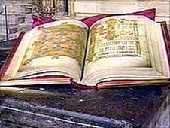
Of far superior vitality were [char] and [char], the former bearing a charmed life throughout Middle English times, though, in the fifteenth century and later, [char] often appeared in the degenerated form of [char], while [char] was retained in order to represent spirant sounds, afterwards denoted by y or gh. During the late twelfth, thirteenth and fourteenth centuries the history of English handwriting was practically that of the various Latin hands of the French school. The fifteenth century finally witnessed the dissolution of the medieval bookhand of the minuscule type, the many varieties of it being apparent in the types used by the early printers. The legal or charter-hand, introduced with the Conquest, was, however, not superseded by the printing-presses, but ran an undisturbed though ever varying course down to the seventeenth century, when its place was taken by the modern current hand, fashioned on Italian models. A late variety still lingers on, however, in the so-called chancery-hand seen in the engraved writing of enrolments and patents. (http://www.bartleby.com/211/0206.html)
Tasks.
- Read the text a Read the text and find some information on the topic of the text to answer the following questions:
- What is characteristic of the uncial hand?
- What is the full name of Bede’s Ecclesiastical History?
- Who was Caedmon?
- Find the keywords.
- Write a short essay about the Venerable Bede, an English monk, a scholar and a writer.
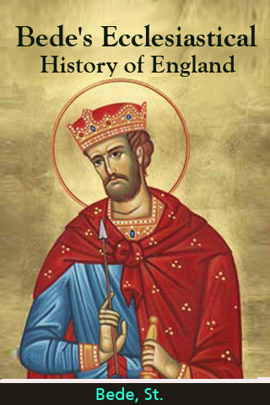
Chapter III
WHERE THE ENGLISH LANGUAGE CAME FROM
(Some historical events that influenced the formation and development of the English language)
Text 1. Roman Britain: Britannia and the Long Arm of Rome
Publius (or Gaius) Cornelius Tacitus (56 AD – 117 AD)
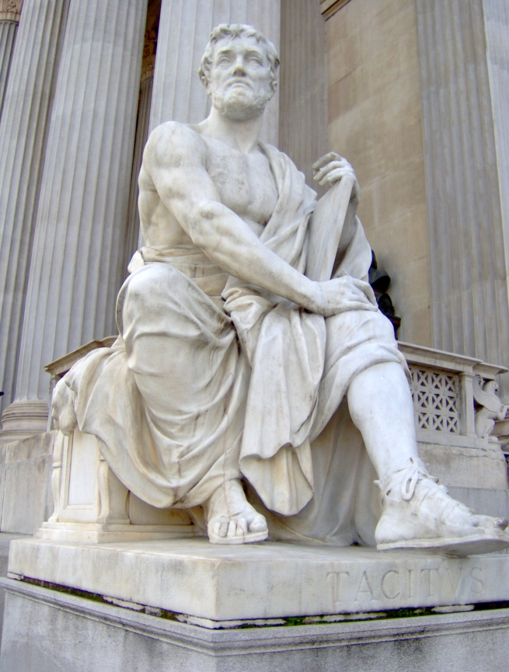
The Roman historian Tacitus described it as pretium victoriae or "worth the conquest." It was the "largest island known to the Romans" and populated with people who "produce gold and silver and other metals." Imperial Rome, it seemed, was only interested in the wealth and resources with which Britannia could provide it. Rome, however, could not have obtained these highly crafted wares from a rudimentary, disjointed society of cave dwellers. Some historians have presented Iron Age Britain as just such a place, but the historical evidence exists to show that pre-Roman Britannia contained a dynamic, growing society of artisans, even though it had not equaled the splendor of Rome.
Gaius Julius Caesar (July 100 BC – 15 March 44 BC)
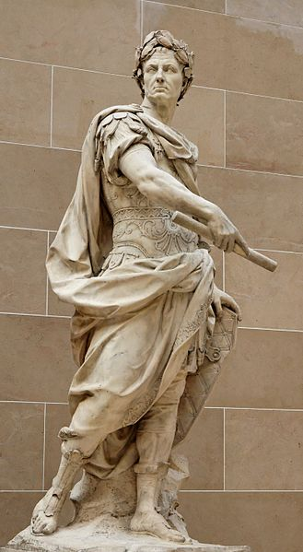
Caesar's Invasions (55 - 54 B.C.). In an attempt to bolster his status among the citizens of Rome, Julius Caesar initiated an invasion of the British Isles in 55 B.C. Caesar's first attempt at invasion was not meant to be, however, as the Roman fleet was turned back by foul weather. He returned again the following year and had a somewhat successful campaign, establishing relations with several regions in southwestern England. This is seen as the first establishment of diplomatic relations between the two countries, and the diplomatic establishment was the only true result of the British invasions led by Caesar.
Tiberius Claudius Caesar Augustus Germanicus (1 August 10 BC – 13 October AD 54)
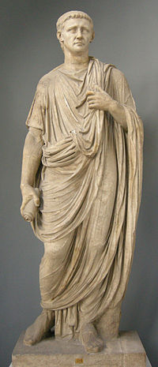
Claudius' Invasion (A.D. 43). The Roman Emperor Claudius saw Britain as an ideal opportunity by which he could expand the empire, take possession of the resources in the British isles, and also gain the prestige associated with the conquest of a new land. He launched an invasion force 40,000 strong in A.D 43, and with such a large invasion force, nothing could stand in the way of the Romans. They met fierce resistance from the British inhabitants at some places, but Rome actively sought to gain willing followers, rather than force them into submission. This policy of peace before war was largely practiced by bribing the residents into cooperation, as most Britons had never seen the level of splendor with which the Romans could lavish them. A prime example of the splendor Rome bestowed on cooperative Britons is the Fishbourne Palace in West Sussex. Such beautiful architecture and workmanship could only be seen in Rome itself, but in order to extend the empire, Roman officials would go to any length.
Rome spent an extended period of enlarging their control over the British isles, through whatever means necessary, and by and large they were successful. The most remembered misstep is evidenced in the story of Queen Boudica and the revolt against Roman control. Boudica's husband had ruled a region of Britain and was a loyal ally of Rome during his life. At his death though, Rome took control of the land rather than let it pass to his wife, Boudica. The Romans flogged and raped her two daughters and in a vengeful rage, Boudica raised an army to revolt against the Romans. They won a few victories initially, but were no match for the disciplined legions in the long run.
Boudica (d. AD 60 or 61)
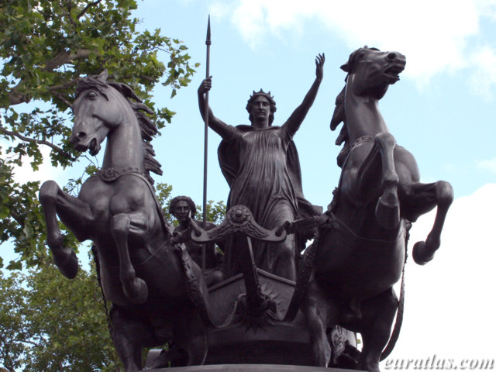
Agricola and Hadrian in Britain. In A.D. 78, Agricola was appointed governor of Brittania, and he continued the conquests there.
Rome's most difficult encounter in Britain occurred in A.D. 79 when the legions face Calgacus on the slopes on Mons Graupius in Northern Britain. Rome quickly learned that the peoples of northern Britannia were much stronger willed than their southern counterparts, for the battles waged in the north of the isles proved to be the limit of Rome's conquest in Britain.
Gnaeus Julius Agricola (40–93)
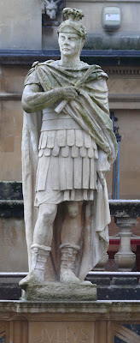
By the time Hadrian came to power in A.D. 117, Rome had essentially withdrawn to an unmarked line in northern England and not advanced any further. Emperor Hadrian placed a strong emphasis on construction and building during his reign, and he was largely responsible for the construction of a wall at the line where the legions had halted their conquest. The wall ended up being approximately 80 miles long, and it served as a control point for movement and commerce in the northern regions Britain. During the Roman occupation of Britain, the two cultures merged to a substantial degree and evidence of that remains to this day.
Publius Aelius Traianus Hadrianus Augustus (24 January, 76 AD – 10 July, 138 AD)
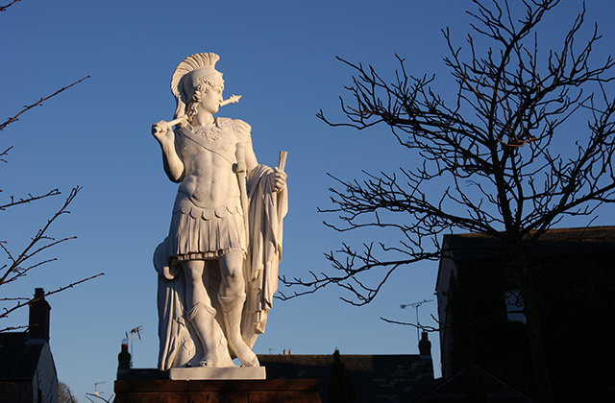
A physical evidence of the cultural combination is seen at the Roman bathhouse, for which the town of Bath was named. Rome also contributed to the English culture in areas such as law and literature. Eventually, the British Isles began to come under threat of incursion by barbarian forces, mainly from Germany and Northern Europe. While Rome still occupied the islands, they built fortification to protect themselves from the invaders. An example of these types of Roman forts is seen in the modern-day city of Portchester.
The Empire Weakens and Rome Takes It's Leave. Rome first arrived in A.D.43 and built their control in Britain gradually over the years. Things in Britain became quite acceptable, both to the Romans and to the Britons. Rome gained the natural resources of the British isles, another region to add to its vast empire, and more subjects to add to the tax base. The Britons in return reaped the gains of urban establishment, in cities such as London and Richborough, and they had gained the protection of the Roman legions from the growing barbarian threat from the North and the West. All good things must come to an end, as the saying goes, and this case did not contradict the trend. Rome itself was feeling the pressure of the growing barbarian presence in the West and it was eventually forced to recall it's legions to Italy in order to defend the Mother City. Although not completely defenseless, the Britons had grown used to the protection of Rome. It is apparent that Rome withdrew almost all of its legions in the early to mid-5th century. An extract from an article by Brandon Huebner (http://www.oglekin.org/Quest/History/After%20the%20Romans%20invade.htm)
Hadrian's Wall, between Birdoswald and Willowford Bridge, Cumbria
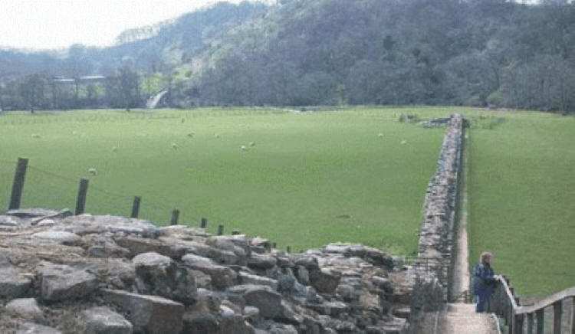
Saxon Shore Fort, Port Chester, Hampshire
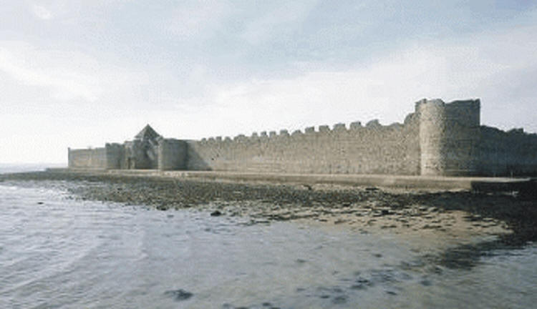
Tasks.
Task 1. Read the lead-in paragraph of the text “Roman Britain: Britannia and the Long Arm of Rome” completely and say what essential information about the article it contains.
Task 2. Read each subheading (Caesar's Invasions (55 - 54 B.C.), Claudius' Invasion (A.D. 43); Agricola and Hadrian in Britain; The Empire Weakens and Rome Takes It's Leave) and look for the relationships among them.
Task 3. Read the first sentence of each remaining paragraph and say whether it is the topic sentence in the paragraph. If not, underline the topic sentence.
Task 4. Dip into the text and find the clue words.
Task 5. Study the proper names and capitalized words, which are used in the text (Britannia, Britons, Emperor Claudius, Fishbourne Palace, Imperial Rome, Iron Age, Julius Caesar, pre-Roman Britannia, Roman, Tacitus, West Sussex, etc.) and say whom or what they denote.
Task 6. Enumerate the events described in the text.
Task 7. Read the final paragraph completely and say if it summarizes the main ideas of the article.
Task 8. What facts given in the article are of special interest to you?
Task 9. Give oral presentation on the theme of the article. OR
Task 10. Write a short essay on the theme of the article.
Text 2. Who were the Celts?
Who were the Celts? Was there ever a distinct people known as the Celts? Was there ever a mass invasion of Celtic peoples into Britain? The word 'Celt' is thought to be derived from the Greek word 'Keltoi' − a name given to a tribe from around the Massilia (Marseille) region of southern France. All other tribes exhibiting similar characteristics were deemed 'Celts'. Recently the term has fallen out of favour and is often replaced by the less romantic but strictly more accurate 'Iron Age peoples'. The term 'Celt' now refers to a type of art − Celtic Art. They were not an 'ethnically distinct group' from the Upper Danube or alpine Europe. In the case of Britain it was as Francis Pryor puts it '... it was more an invasion of ideas than of people'. The original inhabitants of these lands grew and populated the countryside, evolving from the Stone Age through the flooding of the North Sea Basin - recently christened 'Doggerland', to form the islands of Britain in about 5000BC. From the change in being 'hunter-gatherers' to the application of Farming in the Early Neolithic. During the next 2000 years or so, cultures evolved still further with man really making their mark on the landscape with barrows, causewayed enclosures of the Middle Neolithic (c.3500BC) through to the huge henge monuments such as at Stonehenge and Avebury (c.3000BC). As Man developed ever more complex tools and ideas, he discovered the ability to work metals, promoting the next stage in his evolution − The Bronze Age. Some 1500 years later the culture evolved into the Iron Age, with a further increase in the complexity of artifacts and tools. In Britain, the Iron Age is deemed to have ended with the Roman invasion of Emperor Claudius and his legions in AD43. We now move from pre-history into ancient history.
Ancient celtic chieftains
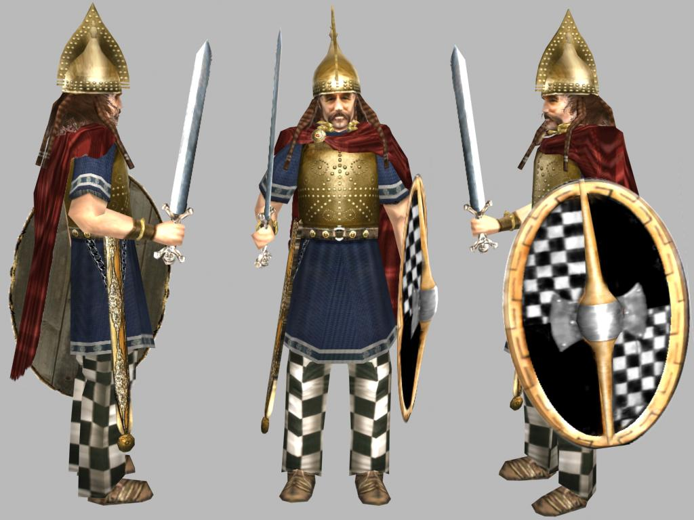
What makes Cornwall and the other 'Celtic' nations so different, so enigmatic, is their very non-Englishness. They stand as somewhere close to home but with different languages, heritage and cultures.
Cornwall is often portrayed as unique to promote tourism - obviously its long beaches of golden sand and spectacular scenery help to put the icing on the cake. Cornwall emerged from the former 'kingdom' of Dumnonia that grew to prominence in the Late Iron Age - from about 150BC.
The rise of the tribal kingdoms had differing effects on their people depending on which part of the British Isles you lived.
The eastern side of the country looked east towards the continent, the western side towards the Atlantic. There seems to have been relatively stable but warlike kingdoms in place by the time of the first tentative expedition by Julius Caesar in 55BC.
Although he brought a force of about 100 ships containing about 10,000 soldiers (2 legions) he did not gain a foothold and returned across the channel to try again the following year.

Doggerland - wet, fishy-smelling and the size of Scotland.
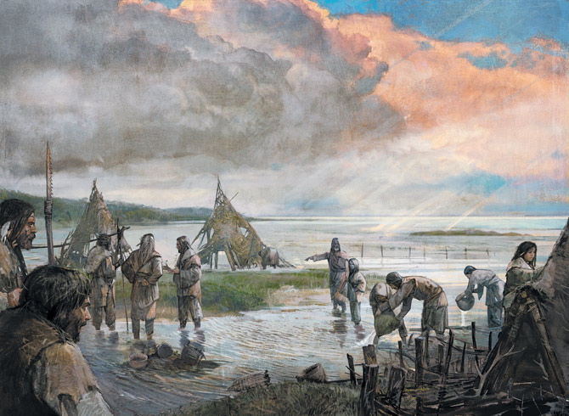
As we explore the topic in search of answers we just keep unearthing more questions. Where do you draw the line between possible fact and pure fiction bolted on by the ancient scribes such as the 6th century Gildas' 'On the Ruin and Conquest of Britain' in c.540AD, the Venerable Bede's 'Historia Ecclesiastica Gentis Anglorum' (c.731AD) and Geoffrey of Monmouth's 'History of the Kings of Britain' of 1136?
St. Gildas Badonicus (AD 500-570)
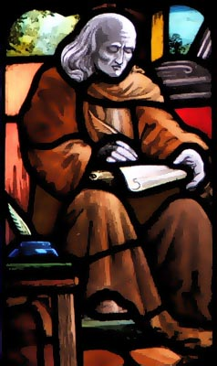
On the shores of the Aegean and eastern Mediterranean, the Greeks and Phoenicians had been trading well since the 8th Century BC. They began to spread westward along the Mediterranean, the Phoenicians choosing to colonize the southern shore from western Sicily to Tunisia, while the Greeks built their colonies along the northern shore from Sardinia to Gades − present day Cadiz.
Geoffrey of Monmouth (c. 1100 – c. 1155)
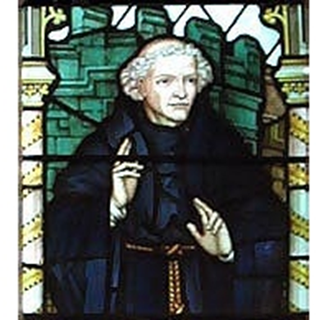
As the two civilizations expanded it was only a matter of time before the 'Celts' and Phoenicians/Greeks encountered each other. A tin-trade route sprang up leading from Cornwall crossing the Channel, through Armorica then taking the 'three river' route along the Seine, Saône and Rhône to the Golfe du Lion. In about 600BC the Greeks founded the port of Massilia (Marseille) near the mouth of the Rhône. Trade increased greatly between the three cultures and each achieved a great deal of power through this commerce.
As Massilia grew, new Atlantic sea routes were opened up across the Bay of Biscay to ensure free flow of trade. The 'Celts' new found wealth was displayed in the quality, diversity and quantity of grave goods found at their burial sites.
An Iron Age culture was spanning from 450 BC to the fall of Gaul in 51 BC. Trade now included wines, fine Etruscan pottery, bronze and iron goods, iron weapons, jewellery and even some gold: Chieftains were even buried with their war chariots. At their greatest extent, around 200 BC, the culture of the Iron Age people formerly known as 'Celts' lay from the Pyrenees east skirting northern Italy and northern Greece to present day Bulgaria.
Trade routes made use of the 7 major rivers of Central Europe, namely Garonne, Rhône, Seine, Saône, Rhine, Po and the upper Danube. The use of iron weapons against less advanced tribes, ensured their supremacy. Trade routes between Egypt and Britain have been proved with the discovery of blue glass beads in Wiltshire identical to those found at Deir el-Bahari and have been subsequently dated at about 1400 BC. (http://www.cornwallinfocus.co.uk/culture/celts.ph
Tasks.
Task 1. Read the lead-in paragraph of the text “Who were the Celts?” completely and say what essential information about the article it contains.
Task 2. Divide the text into paragraphs. Remember that each paragraph should develop a particular theme. Give a title of each paragraph.
Task 3. Read the first sentence of each paragraph and say whether it is the topic sentence in the paragraph. If not, underline the topic sentence.
Task 4. Dip into the text and find the clue words.
Task 5. Study the proper names and capitalized words, which are used in the text (Avebury, Celts, Doggerland, , Francis Pryor, the Stone Age, Stonehenge, Cornwall, etc.) and say whom or what they denote.
Task 6. Enumerate the events described in the text.
Task 7. Read the final paragraph completely and say if it summarizes the main ideas of the article.
Task 8. What facts given in the article are of special interest to you?
Task 9. Give oral presentation on the theme of the article. OR
Task 10. Write a short essay on the theme of the article.
Text 3. Women in Ancient Celtic Society
Celtic society was hierarchical and tribal; therefore, we must remember that the role of women (and men) was dictated by their place in the social hierarchy and the customs which varied according to tribe. Moreover, Celtic society was patriarchal, as indicated by the Brehon laws; its political and public life was largely the domain of men.
J E Millais, The Bridesmaid, 1851 A Druid Priestess
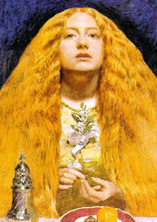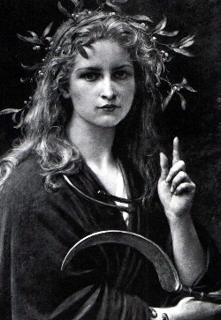
Nevertheless, despite this, it is evident that many women in Celtic society held positions of authority, enjoying a high status, and compared with their Roma and Greek counterparts they were afforded many more freedoms.
Celtic women served as chieftains, druids, poets, healers and warriors; they served as diplomats and judges; and they served as arbitrators, mediating in political and military disputes and in tribal assemblies. Those who were married had unparalleled rights of property and divorce unlike Roman women who left their fathers homes only to become the property of their husbands.
Celtic women could not be married against their will and were free to make their own choice of husband. The year-long trial marriages that began at the festival of Samhain could be dissolved if they proved impracticable; divorce was a relatively simple matter that could be requested by either party and women were free to remarry.
Queen Medb, J Leyendecker, c.1916 Boudicca
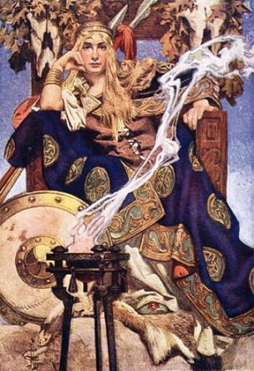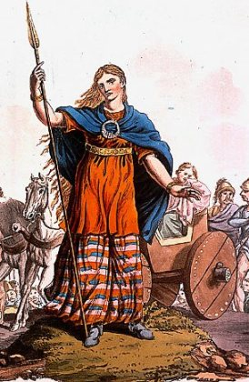

Celtic women possessed the right to bear arms and this was common practice. Wives often accompanied their husbands into battle. In battle, they made great use of psychological tactics to disconcert the enemy such as screeching and dancing wildly. There are numerous accounts of Celtic warrior women and their achievements in battle.
The Greek historian, Ammianus Marcellinus (c.400 AD) describes Celtic women warriors as: “usually very strong, and has blue eyes; in rage her neck veins swell, she gnashes her teeth, and brandishes her snow-white robust arms. She begins to strike blows mingled with kicks, as if they were so many missiles sent from the string of a catapult. The voices of these women are formidable, even when they are not angry but being friendly.”
Queen Medb with a druid (left) and Queen Macha (right), Stephen Reid, c.1910
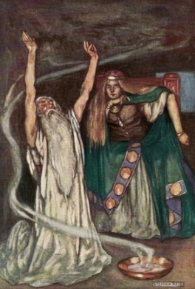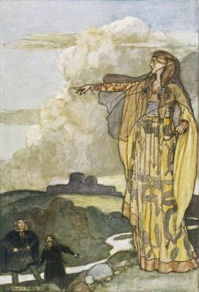
Some Celtic women were ruling queens and military leaders. Boudicca, also known Boadicea, is probably the best known. She became ruler of a Celtic tribe called the Iceni and led the last major revolt against the Romans in Britain. In Ireland, a well-known powerful female ruler was Medb (or Maeve), Queen of Connaught; her authority, as queen over nine kings, was absolute. Some women became teachers of the art of war such as Scathach, the warrior who trained the greatest hero of Irish legend, Cúchulainn.
Many such Celtic women were strong and powerful and played prominent roles, testament to the high regard in which they were held. These women were distinct in the ancient world for the liberty and rights they enjoyed and position they held in society. Now they serve us, by offering women of the present an inspiring and intriguing example of strong womanhood from the past. (http://www.celticquill.com/history/52-women-in-celtic-society).
Tasks.
Task 1. Read the lead-in paragraph of the text “Women in Ancient Celtic Society” completely and say what essential information about the article it contains.
Task 2. Match the headings given below with the paragraphs.
a. The Celtic women warriors.
b. The Celtic women leaders.
c. The social freedoms awarded to Celtic women.
d. The conditions of marriage.
Task 3. Read the first sentence of each paragraph and say whether it is the topic sentence in the paragraph. If not, underline the topic sentence.
Task 4. Dip into the text and find the clue words.
Task 5. Study the proper names and capitalized words, which are used in the text (the Brehon laws, Samhain, Ammianus Marcellinus, Boudicca, the Iceni, Medb (or Maeve), Queen of Connaught, Scathach etc.) and say whom or what they denote.
Task 6. Enumerate the facts described in the text.
Task 7. Read the final paragraph completely and say if it summarizes the main ideas of the article.
Task 8. What facts given in the article are of special interest to you?
Task 9. Give oral presentation on the theme of the article. OR
Task 10. Write a short essay on the theme of the article.
Text 4. The Rise of Rome
In about 510 BC Rome expelled the Etruscan kings and became a republic. Growth was slow for the next century or so and it didn't really speed up until after the battles of Clusium and Allia in 390 BC. The Celts (Gauls) under Brennus continued their advance and sacked Rome in 387 BC. Complete capture of the city only being avoided by the fortuitous warning given by a startled gaggle of geese.
The Romans rebuilt their city, surrounding it with a city wall and from now on gradually increased their powerbase through systematic treaties or defeat of their nearest neighbours. They fought three wars against the Samnites [343-341 BC, 326-304 BC and 298-290 BC] receiving Capua and capturing the Samnite capital of Bovianum in 298 BC. The third war saw the Samnites enter into a loose coalition with the Etruscans, Celts (Gauls), Sabines, Lucanians and Umbrians.
The Gallic leader Brennus, as depicted on the figurehead of the battleship named after him
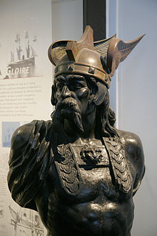
Over the next eight years the Romans defeated each of the coalition members individually and their hold on central Italy was ensured. From 285-282 BC the Romans fought with the Celts of northern Italy, conquering the Gallic Senones in 282 BC. Turning their attention south, Rome attacked Tarentum and King Pyrrhus of Epirus defeating them over the next ten years.
King Pyrrhus of Epirus
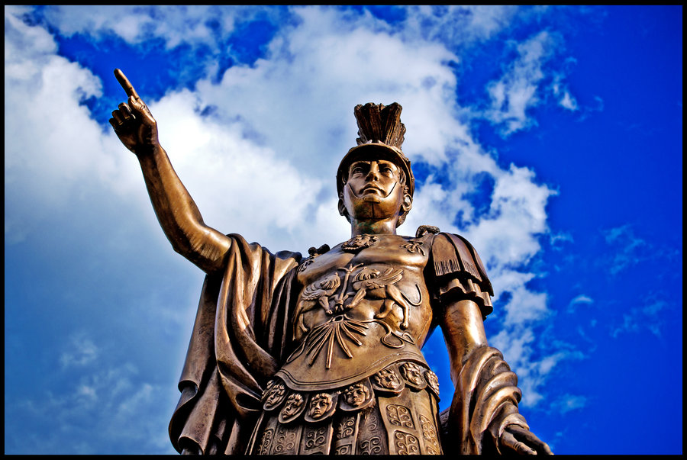
The Greek cities of southern Italy were either captured or now pledged their allegiance to Rome. Rome now controlled the majority of the Italian peninsula. Shortly afterwards the Romans would be at war once again. The Carthaginians (descendants of the original Phoenicians) were attacked and defeated during the Three Punic Wars [261-241 BC, 218-201BC and 149-146 BC].
(http://www.cornwallinfocus.co.uk/culture/celts1.php)
Tasks.
Task 1. Read the lead-in paragraph of the text “The Rise of Rome” completely and say what essential information about the article it contains.
Task 2. Give a title of each paragraph. Remember that each paragraph should develop a particular theme.
Task 3. Read the first sentence of each paragraph and say whether it is the topic sentence in the paragraph. If not, underline the topic sentence.
Task 4. Dip into the text and find the clue words.
Task 5. Study the proper names and capitalized words, which are used in the text (the battles of Clusium and Allia, Brennus, the Samnites, Capua, the Gallic Senones, etc.) and say whom or what they denote.
Task 6. Enumerate the events described in the text.
Task 7. Read the final paragraph completely and say if it summarizes the main ideas of the article.
Task 8. What facts given in the article are of special interest to you?
Task 9. Give oral presentation on the theme of the article. OR
Task 10. Write a short essay on the theme of the article.
Gaul, Senones AV Stater. 7.36g, 13mm. Gallo-Belgic Bullet Type.
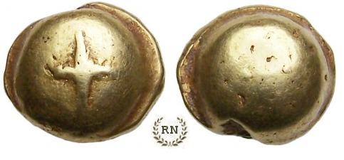
Text 5. British Iron Age (from the 8th century BC to the 1st century AD)
The Dumnonii occupied all of Cornwall and most of Devon. Their capital was at Isca Dumnoniorum - present day Exeter. The tribe was engaged chiefly in metal working especially tin mining. The Dumnonii were bounded on the east by the Durotriges. The tourist attraction of St. Michael's Mount is thought to be the site of the ancient port of Ictis, where tin was traded with sea-faring traders such as the Phoenicians.
The Durotriges occupied East Devon, West Somerset, Dorset and South Wiltshire. Their capital was at Durnovaria - present day Dorchester. The tribe was noted for its well positioned large hillforts - such as at Maiden Castle. There was another walled settlement at Lindinis (Ilchester).
The Belgae occupied Hampshire and East Somerset. Their capital was at Venta Belgarum - present day Winchester. The tribe was mainly a loose grouping of Belgic peoples descended from the Northern Gauls. Their other main settlements are at Bath and at Vectis - the Isle of Wight. They were bounded to the northeast by the Dobunni and the east by the Atrebates.
A roundhouse, the typical building on a settlement. All of the domestic life would have occurred within this.
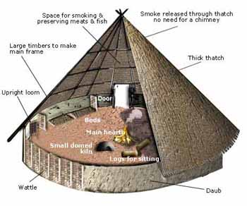
The Dobunni occupied Gloucestershire and parts of East Somerset and Avon, stretching into the southern parts of Herefordshire, Worcestershire and Warwickshire. Their capital was at Corinium Dobunnorum - present day Cirencester. The tribe were a grouping of Non-Belgic peoples also noted for their outstanding hillforts. Their other main settlements were Ariconium in the Forest of Dean and at Wanborough, Wiltshire - Durocornovium. They were bounded to the southeast by the Atrebates and to the north by the Cornovii.
The Atrebates tribe were a Belgic people descended from, and having close connection with, the tribes of north west Gaul (centered on the area around present-day Arras). They were based in eastern Hampshire and Berkshire as well as the western parts of Surrey and Sussex. Their capital was at Calleva Atrebatum - Silchester, Hampshire.
The tribe was one of the few Celtic tribes to have issued coinage, just prior to the Roman invasion. One of their major chieftains was Commius. The Atrebates were bounded to the north by the Catuvellauni and the east by the Cantii.

The town of Calleva Atrebatum, now called Silchester was established by the Atrebates
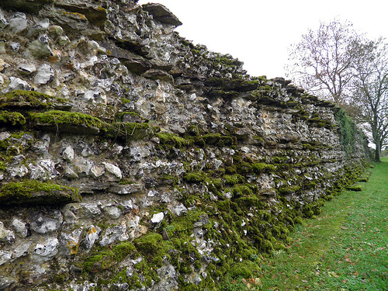
The Catuvellauni originally occupied Hertfordshire around Verulamium (St Albans). Under their strong leader Cunobelin, they attacked and eventually subjugated the Atrebates, becoming one of the major players in Southern Central Britain. The leader of the Atrebates, one Verica, son of Commius, a former client king of the Romans, fled to the continent and asked the Roman Emperor Claudius for help to repel the Catuvellauni. This gave Claudius just the excuse he needed to invade Britain in 43AD. Their kingdom was surrounded by the Dobunni, Atrebates, Coritani, the Iceni and the Cantii (Cantiaci).
The Cantii or Cantiaci, occupied the southeastern corner of Britain and gave their name to the present county of Kent. Their capital was at Durovernum Cantiacorum - Canterbury. The tribe had strong links with their Belgic cousins across the water but were also regarded by Caesar as the 'most civilised people in Britain' - maybe due to their proximity to continental Europe. Due to their empathy with the Romans, much more is known about these people than any other tribe in Britan. Their main settlements were at Durobrivae (Rochester) and Rutupiae (Richborough). Their main ports were at Dubris (Dover) and Lemanis (Lympne).
Durovernum Cantiacorum - Canterbury
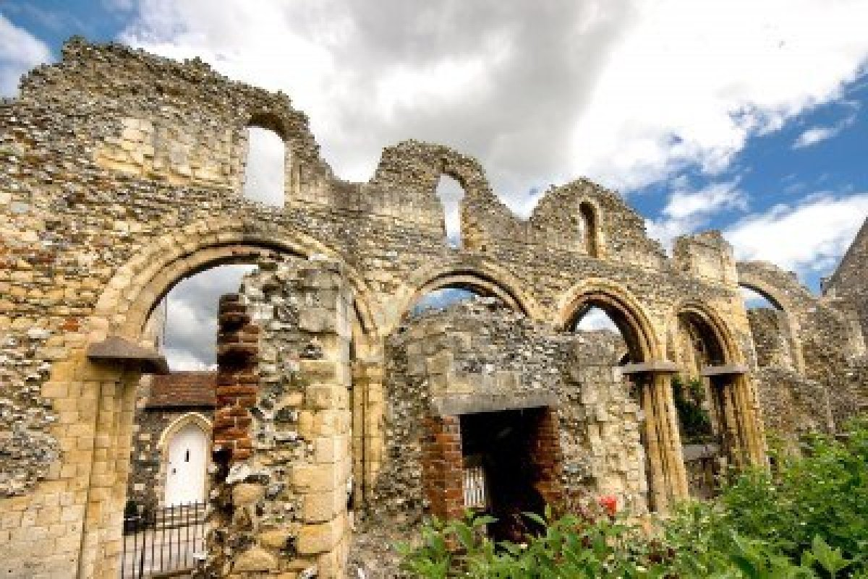
The Iceni along with the Trinovantes occupied what is now East Anglia. The Iceni kingdom based in Norfolk and North West Suffolk with their allies based at Caesaromagus, occupying southern Suffolk and Essex. Their capital was at Venta Icenorum - Caister St. Edmund, Norfolk, with another major settlement at Thetford. The tribe is probably the best known ancient tribe in Britain due to the exploits of the Warrior Queen Boudica in the revolt of the Iceni of AD60. With their allies, the Trinovantes the Iceni attacked and plundered many Roman towns including Camulodunum, Verulamium and Londinium before being crushed by a much smaller Roman force under the astute leadership of Suetonius Paulinus.
The Coritani were the name given to the Iron Age tribes occupying a large region stretching from South Yorkshire through Lincolnshire, Nottinghamshire and Leicestershire. They were not a close knit tribe but more a group sharing the same values. Their main industry was agriculture and they accepted Roman rule when it came with no complaints. Their capital was at Ratae Corieltauorum - Leicester. They are another people with a defined Monarchy and Coinage unlike their counterparts in Western Britain. Another major settlement was at Lindum - Lincoln. The links they were to forge with the Romans helped to protect them from their warlike neigbours the Brigantes of Northern Britain.
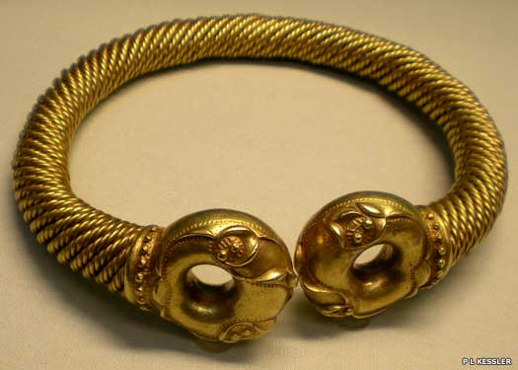
A Celtic gold and silver-alloy torc, discovered near Newark, Nottinghamshire, in Coritani territory, and probably worn by a Coritani prince or king between 100-50 BC
The Brigantes were the dominant tribe in Northern England. They are thought to have their ancestral roots in Germany or north eastern Gaul. Their capital was at Isurium Brigantum - Aldborough in North Yorkshire.
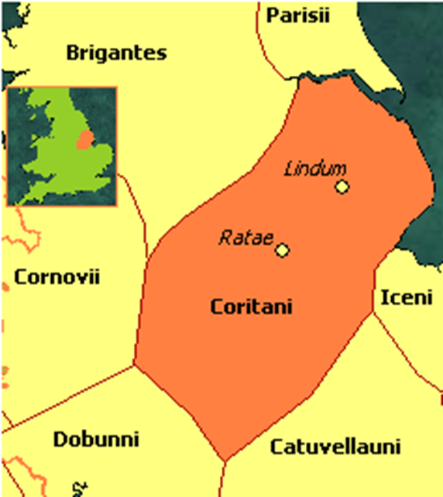
They were a warlike people who defied Rome on many occasions until defeated by Ostorius. Following this failed revolt they too became a client kingdom of Rome. The Brigantes also had a defined Monarchy but inter-family rivalries caused their society to be somewhat unstable.
Other major settlements were at Calcaria - Tadcaster and Luguvalium - Carlisle. After the break with the Carvetii, Luguvalium became the capital of that faction.
Approximate territory of the Brigantes
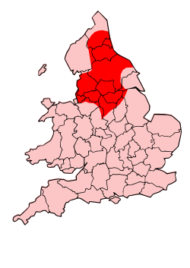
The Parisi or Parisii occupied a small area centred on Humberside sandwiched between the Brigantes to the north and the more advanced Coritani to the south. Their capital was at Peturia and it is thought they descended from the tribes of north-central Gaul - and incidentally gave their name to the French capital.
The Cornovii occupied quite a large area centred on Shropshire between the Carvetii to the north and the Dobunni to the south. Their capital was at Viroconium Cornoviorum (Wroxeter). They were builders of some outstanding hillforts and also their fine pottery. Copper and Silver-Lead mines were also among their industries. Their capital was the fourth largest town in Roman Britain. Other major settlements were at Deva Victrix - Chester and Bovium - Tilston in Cheshire.
Viroconium Cornoviorum – Wroxeter baths complex.
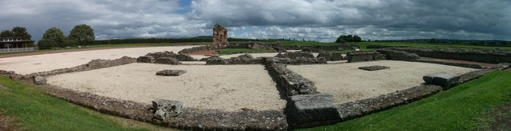
The Carvetii occupied Cumbria and northern Lancashire but also had lands stretching into present day Scotland. Historical texts place them initially as a grouping within the Brigantes being given their own status during Roman rule. They are bordered to the north by the Selgovae, Novantae and Votadini tribes and to the south and east by the Brigantes. Their capital was at Luguvalium - present day Carlisle.
Gadfael Ordovices.
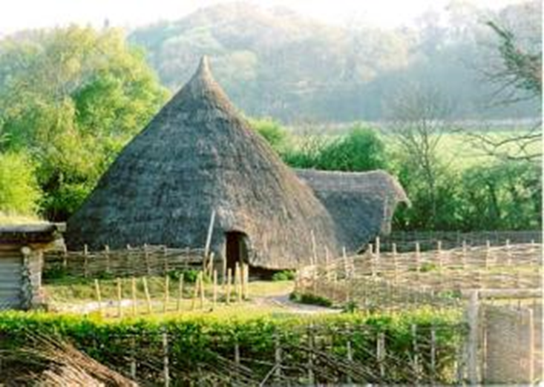
The Ordovices along with the Silures occupied most of Wales. The Ordovician kingdom in southern Gwynedd and Clwyd had no true capital but their neighbours based in Gwent had their capital at Venta Silurum, Caerwent. Both tribes were prolific hillfort builders, with the forts of the Silures showing characteristics from their neighbours across the Bristol Channel. The Deceangi and Demetae occupied the remainder of Wales.
The Deceangi kingdom of north-east Wales (north Gwynedd and Clwyd) had no true capital. Its population spread within its numerous hillforts. The Demetae were based in southwest Dyfed, with their capital at Moridunum, Carmarthen. Both tribes were prolific hillfort builders, with the forts of the Demetae showing characteristics from their brethren in southwest England. (http://www.cornwallinfocus.co.uk/culture/celts3.php)
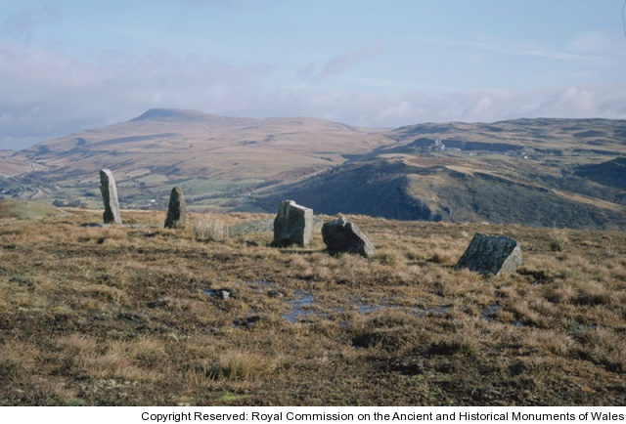
Tasks.
Task 1. Read the lead-in paragraph of the text “British Iron Age” completely and say what essential information about the article it contains.
Task 2. Give a title of each paragraph. Remember that each paragraph should develop a particular theme.
Task 3. Read the first sentence of each paragraph and say whether it is the topic sentence in the paragraph. If not, underline the topic sentence.
Task 4. Dip into the text and find the clue words.
Task 5. Study the proper names and capitalized words, which are used in the text (Atrebates, the Belgae, Durotriges, Dumnonii, Isca Dumnoniorum, Maiden Castle, etc.) and say whom or what they denote.
Task 6. Enumerate the events described in the text.
Task 7. Read the final paragraph completely and say if it summarizes the main ideas of the article.
Task 8. What facts given in the article are of special interest to you?
Task 9. Give oral presentation on the theme of the article. OR
Task 10. Write a short essay on the theme of the article.
Text 6. A History of Modern and Extinct Celtic Languages
The evolution and history of the Celtic languages is interesting and somewhat chequered. Celtic languages are descended from the Indo-European stock of languages, which developed into most of the languages that the 'westernized world' speaks today, including English, Spanish, German, French, Russian and so on.
The Proto-Celtic language − the first Celtic language that arose from the Indo-European common ancestor − was spoken all over the western continent of Europe. The people who spoke it soon began to die out or to be culturally assimilated by the growing Roman Empire (circa 200 BC).
The Gauls in fact, were the last known mainland Europeans to speak some form of Celtic. Before all the Celtic speakers were eradicated or integrated, some of them migrated to the British Isles. This signifies the first major division of the Celtic languages.
Now Continental Celtic is spoken by the Gauls and other mainlanders, and Insular Celtic, spoken by occupants of the British Isles. The oldest known Insular Celtic language is Old Irish or Goedelic (Gaelic), which eventually became the Irish Gaelic language of today.
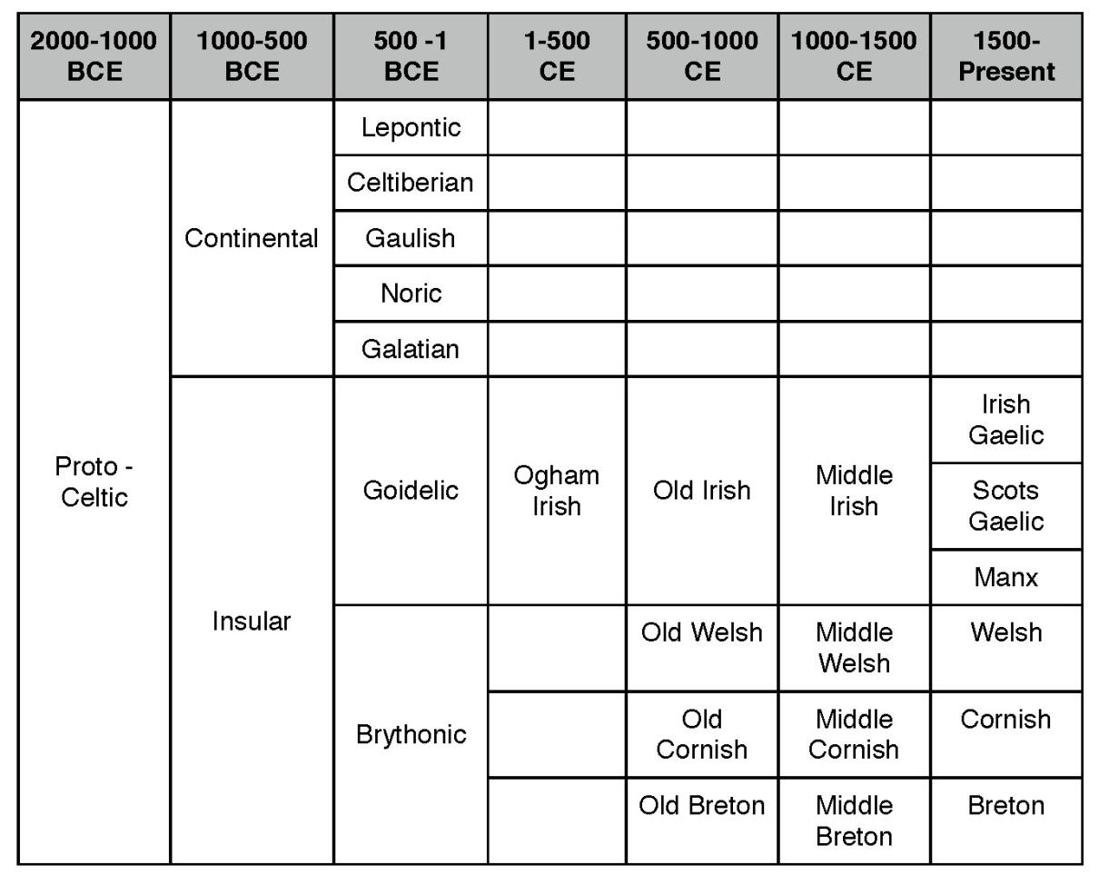
When settlers moved to what is today mainland Britain, Goedelic became Brythonic. Goedelic and Brythonic are the two major divisions of Celtic that provide the basis for all surviving Celtic languages.
Breton Gospel Book
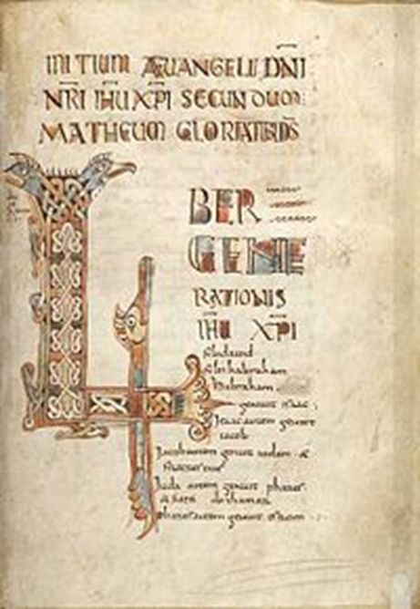
When the Irish started to migrate into what is now Scotland, a distinct language, Scottish Gaelic developed. A similar process occurred for those people who inhabited the Isle of Man, who now speak Manx. So there you have the Goedelic Celtic languages: Irish Gaelic, Scottish Gaelic and Manx.
Brythonic, the root for the mainland British languages, also developed into three modern Celtic languages (of which only two survive). Welsh is spoken in Wales and is actually the most widely spoken of the Celtic languages. Cornish also derived from Brythonic Celtic and was spoken in a small region of south-western Britain, and almost died sometime in the 19th century.
However, the language underwent a revival in the latter half of the 20th century. Breton was the third Brythonic Celtic language to develop.
Breton, although an Insular Celtic language, is actually spoken on continental Europe; in France, to be exact. However, its roots are still from the Brythonic languages. As the history goes, in about 600 AD Britain was invaded by pagan tribes from western Germany, called the Saxons. While the Saxons were sweeping part of southern Britain, some of the natives picked up and left. They landed in north-western France, where their Celtic heritage and language still have an influence on local culture and daily life.
The Continental Celtic people
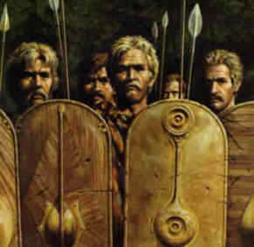
Tasks.
Task 1. Read the lead-in paragraph of the text “A History of Modern and Extinct Celtic Languages” completely and say what essential information about the article it contains.
Task 2. Match the headings given below with the paragraphs.
a. Continental Celtic and Insular Celtic.
b. The roots of Breton.
c. How the Celtic language appeared in Britain.
d. Celtic languages derived from Brythonic.
Task 3. Read the first sentence of each paragraph and say whether it is the topic sentence in the paragraph. If not, underline the topic sentence.
Task 4. Dip into the text and find the clue words.
Task 5. Study the proper names and capitalized words, which are used in the text (Brythonic, Brythonic, Celtic, Gauls, Goedelic Proto-Celtic, Manx, etc.) and say whom or what they denote.
Task 6. Enumerate the facts described in the text.
Task 7. Read the final paragraph completely and say if it summarizes the main ideas of the article.
Task 8. What facts given in the article are of special interest to you?
Task 9. Give oral presentation on the theme of the article. OR
Task 10. Write a short essay on the theme of the article.
Celtic Triple Spiral Clip Art
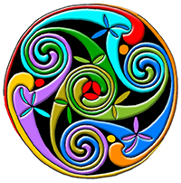
References
- Аракін, В.Д. Історія англійської мови: Навчальний посібник / В.Д. Аракін. − М .: ФИЗМАТЛИТ, 2011. − 304 c.
- Аракін, В.Д. Історія англійської мови / В.Д. Аракін. − М.: Физматлит, 2011. − 304 c.
- Бруннер, К. Історія англійської мови: Два томи в одній книзі / К. Бруннер; Під ред. і з предисл. Б.А. Ильиш; Пер. з нім. С.Х. Васильєва. − М.: ЛКИ, 2010. − 720 c.
- Германова, М.М. Історія нормування англійської мови: Лінгвокультурні підстави британської нормативної граматики. / М.М. Германова. − М.: Ленанд, 2014. - 368 c.
- Долгова, А.О. Історія англійської мови: електро. навчально-метод. посібник для студентів спеціальності «Сучасні іноземні мови ». − Мінськ, БДУ. − Електр. Бібліотека БГУ. − Режим доступу:
http://elib.bsu.by/handle/123456789/10663 − Дата доступу: 01.09.2017.
- Іванова, І.П. Історія англійської мови: Підручник / І.П. Іванова, Л.П. Чахоян, Т.М. Бєляєва. − СПб .: Азбука, Авалон, 2010. − 560 c.
- Іванова, І. П. Практикум з історії англійської мови [Текст]: навчальний посібник / І.П. Іванова, Т.М. Бєляєва, Л.П. Чахоян. − Санкт-Петербург: Изд-во "Лань", 2001. − 160 с.
- Красухин, К.Г. Історія англійської мови та введення в німецьку філологію: Короткий нарис: Навчально-методичний посібник / К.Г. Красухин. − М .: Флінта, 2016. − 104 c.
- Расторгуєва, Т. А. Історія англійської мови [Текст]: підручник / Т. А. Расторгуєва. 2-е изд., Стереотип. − Москва: Астрель: АСТ, 2003. − 350 с.
- Резник, Р. В. Історія англійської мови [Текст] = A History of the English Languge: навчальний посібник / Р.В. Резник, Т.А. Сорокіна, І.В. Резник. − Москва: Флінта: Наука, 2001. - 496 с.
- Телегін, Л.А. Історія англійської мови: Навчальний посібник для бакалаврів / Л.А. Телегін, Д.А. Телегіна, Е.Д. Павличев. − М .: Флінта, 2016. − 160 c.
- Хлєбнікова, І. Б. Введення в німецьку філологію та історію англійської мови [Текст]: навчальний посібник / І.Б. Хлєбнікова. − Москва: ЧеРо, 2001. − 184 с.
- Baugh A.C. A History of the English Language. Vol. 1-2. / A.C. Baugh – N.Y., 1978. – 249 р.
- Brook G.S. A History of the English Language. / Brook G.S. – L., 1997. – 167 р.
- Crystal D. The Cambridge Encyclopedia of the English Language Cambridge / D. Crystal. − London, 1999. − 897 с.
- Daniels, Peter T. The World's Writing Systems / Peter T. Daniels, Oxford University Press, 1996 – 920 p.
- Gramley St., Pätzold K-M. A survey of Modern English / Gramley St., Pätzold K-M. - London: Routledge, 1996. − 656 с.
- Nakanishi, Akira. Writing Systems of the World / Akira Nakanishi, Tuttle Publishing, 1990 – 122 p.
- Oxford Guide to British and American culture for learners of English / Editor Jonathan Crowther, Kathryn Kavanagh. – Oxford: Oxford University Press, 1999. – 600 p.
- Wild C. A. History of Modern Colloquial English / C. A.Wild. − Oxford, 1953. −389 с.

